A PROJECT REPORT

ON

MOVIE RECOMMENDATION SYSTEM

*Submitted for the partial fulfilment of the requirement for the award of the degree of*

BACHELOR OF TECHNOLOGY IN

COMPUTER SCIENCE & ENGINEERING

### SUBMITTED BY:

#### Rishabh Gupta (1849210073)

### SUPERVISED BY

**Ms. Arti Tiwari**

ASSISTANT PROFESSOR(CSE)



### DEPARTMENT OF COMPUTER SCIENCE & ENGINEERING KCC INSTITUTE OF TECHNOLOGY AND MANAGEMENT GR. NOIDA

**SESSION 2021-22**

## ACKNOWLEDGEMENT

It gives us a great sense of pleasure to present the report of the B. Tech Major Project undertaken during B. Tech. Fourth Year.

I would like to express my special thanks to **Ms. Arti Tiwari**, **Asst. Professor and Project Supervisor** of **KCC Institute of Technology & Management Gr. Noida**, for her insight and knowledge on the subject, who imbued us with the feeling to work assiduously.

I am also indebted to all the teaching and non-teaching staff members of my college for helping me directly or indirectly by all means throughout the course of my study and project work. Finally, I take this opportunity to thank my friends for their moral support and help and extended thanks to my well-wishers.

**Rishabh Gupta (1849210073)**

## DECLARATION

I, **Rishabh Gupta (1849210073)** hereby declare that the work which is being presented in the project report **“Movie Recommendation System”** is the record of authentic work carried out by us during the period from January ’15 to May ’15 and submitted by me in partial fulfilment for the award of the degree **“Bachelor of Technology** in **Computer Science and Engineering”** to **KCC Institute of Technology & Management Gr. Noida.** This work has not been submitted to any other University or Institute for the award of any Degree/Diploma.

**Rishabh Gupta (1849210073)**

## TABLE OF CONTENTS

|  |
| --- |
| **Chapter No. Page No.**  Certificate.......................................................................................................... 1  Acknowlegement............................................................................................... 2  Declaration......................................................................................................... 3  Abstract.............................................................................................................. 6  List of figures..................................................................................................... 7 |
| **Chapter 1: Introduction** |
| 1.1 General Recommendation system ............................................ 8  1.2 Drawbacks of Existing Recommendation System.................... 8 |
| 1.3 Proposed Recommendation System......................................... 9 |
| 1.4 Features of Proposed Recommendation System....................... 10 |
| 1.5 Importance of Proposed Recommendation System................. 10 |
| **Chapter 2 : Literature Survey** |
| 2.1 Introduction............................................................................. 12  2.2 Related Work........................................................................... 13  2.3 Conclusion............................................................................... 17  **Chapter 3 : Problem Description**  3.1 Problem Statement………………………………………... 18 |

3.1.1 Limitations of Existing System…………………….…... 19

3.2 Proposed Solution………………………………………… 21

Chapter 4 : Methodology

4.1 System Specifications……………………………………….. 22

4.2 Initial Overview……………….…………………………... 23

4.3 Analysis……………….…………………………………... 26

|  |
| --- |
| **Chapter 5: Implementation** |
| 5.1 Datasets used ..................................................................... 28  5.2 Walkthrough of building a recommender system.............. 28 |
| **Chapter 6: Output**   * 1. Output in Jupyter Notebook………………….…………… 41   2. Output of Build and design in PyCharm………………... 59   3. Heroku Dashboard & Web Application ..……………….. 61   **Chapter 7: Conclusion and Future Work** |
| 7.1 Conclusion......................................................................... 65  7.2 Future Work...................................................................... 66 |
| **References**................................................................................................. 67 |

**ABSTRACT**

Recommender System is a tool helping users find content and overcome information overload. It predicts interests of users and makes recommendation according to the interest model of users.

The original content-based recommender system is the continuation and development of collaborative filtering, which doesn’t need the user’s evaluation for items. Instead, the similarity is calculated based on the information of items that are chose by users, and then make the recommendation accordingly. With the improvement of machine learning, current content-based recommender system can build profile for users and products respectively. Building or updating the profile according to the analysis of items that are bought or visited by users. The system can compare the user and the profile of items and then recommend the most similar products. Hence this recommender method that compare user and product directly cannot be brought into collaborative filtering model. The foundation of content-based algorithm is acquisition and quantitative analysis of the content. As the research of acquisition and filtering of text information are mature, many current content-based recommender systems make recommendation according to the analysis of text information.

**Keywords**: Cosine-Similarity, Tags, CountVectorization, scikit-learn, APIs, Streamlit, Content-based filtering, evaluation, Text Classification, Vector space model.

## LIST OF FIGURES

* Figure 1.3 Dataframe for movies and credits.
* Figure 1.5 Euclidian Distance and Cosine Similarity
* Figure 2.2 Related Work: Benefits of Recommendation System in Corporate Sector
* Figure 2.3 Examples of Recommendation Systems used by companies
* Figure 4.1 System Specification Tables
* Figure 4.2 Recommender system in e-commerce
* Figure 5.2 Walkthrough of Code outputs
* Outputs:
  + Jupyter Notebook code
  + Build and Design in PyCharm
  + Heroku Dashboard & Web Application

### CHAPTER 1: INTRODUCTION



* 1. **General Recommendation System**

In the era of information overload, it is very difficult for users to get information that they are really interested in. And for the content provider, it is also very hard for them to make their content stand out from the crowd. That is why many researchers and companies develop Recommender System to solve the contradiction. The mission of Recommender System is to connect users and information, which in one way helps users to find information valuable to them and in another way push the information to specific users. This is the win-win situation for both customers and content providers.

A recommender system is a simple algorithm whose aim is to provide the most relevant information to a user by discovering patterns in a dataset. The algorithm rates the items and shows the user the items that they would rate highly. An example of recommendation in action is when you visit Amazon and you notice that some items are being recommended to you or when Netflix recommends certain movies to you. They are also used by Music streaming applications such as Spotify and Deezer to recommend music that you might like.

### Drawbacks Of Existing Recommendation System

* + - Euclidian Distance is used to calculate the similarity between products/services which is very complicated in high dimensional dataset and often results in low accuracy.
    - Some time data present in dataset may be incorrect thus, leading to the incorrect information analysis.
    - Limited training data leads to low accuracy
    - Data Analysis and cleaning isn’t performed well before training.

### Proposed Recommendation System

The project introduces content-based recommender system and its deployment as a web application. There are a lot of features that are extracted from the movie dataset and credit dataset, they are in diversity and unique, which is also the difference from other recommender systems. We use these features to construct tags for each movie.

We introduce an optimized approach for setting weight of features, which improves the representative of movies.

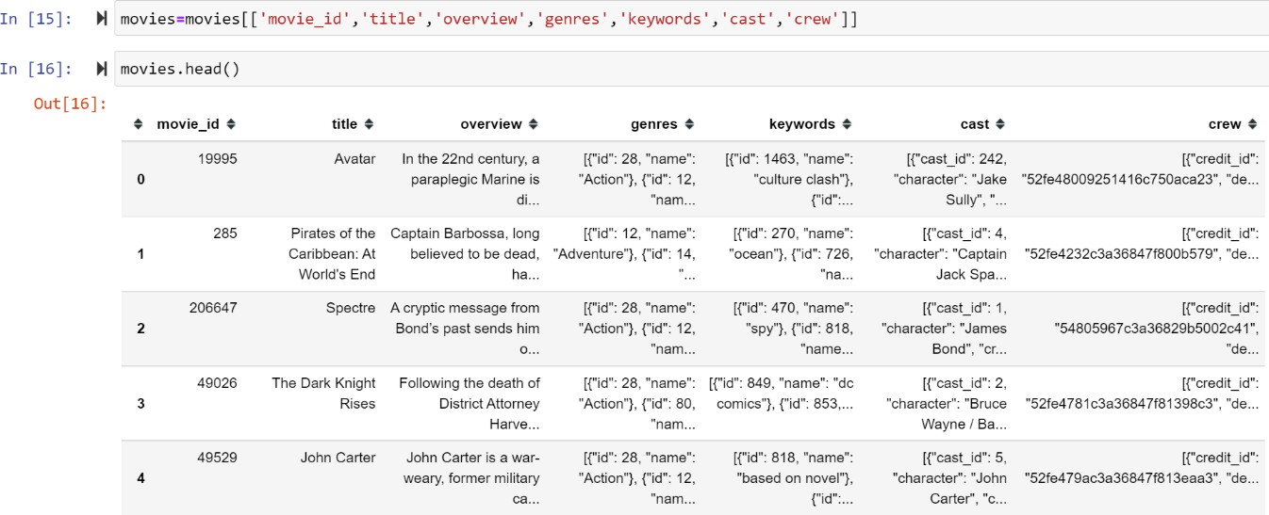

### Features Of Proposed Recommendation System

* + - The ability to predict whether a particular user would prefer an item or not based on the user's profile.
    - End-to-end deployment of the web application across multiple devices.
    - Latest (official) Posters fetched from the official sites for visual gratification.
    - More accurate recommnendations taking into account more features such as actors or director specific.

### Importance of Proposed Recommendation System

The explosive growth in the amount of available digital information and the number of visitors to the Internet have created a potential challenge of information overload which hinders timely access to items of interest on the Internet. Google, DevilFinder and Altavista have partially solved this problem but prioritization and personalization (where a system maps available content to user’s interests and preferences) of information were absent. This has increased the demand for more than ever before. Recommender systems are information filtering systems that deal with the problem of information overload by filtering vital information fragment out of large amount of dynamically generated information according to user’s preferences, interest, or observed behavior about item.

Recommender system has the ability to predict whether a particular user would prefer an item or not based on the user’s profile.

Recommender systems are beneficial to both service providers and users. They reduce transaction costs of finding and selecting items in an online shopping environment. Recommendation systems have also proved to improve decision making process and quality. In scientific libraries, recommender systems support users by allowing them to move beyond catalog searches. Therefore, the need to use efficient and accurate recommendation techniques within a system that will provide relevant and dependable recommendations for users cannot be over-emphasized.

The proposed recommendation system improves decision making process for the user by by filtering vital information according to user’s preferences, interest, or observed behavior about item.

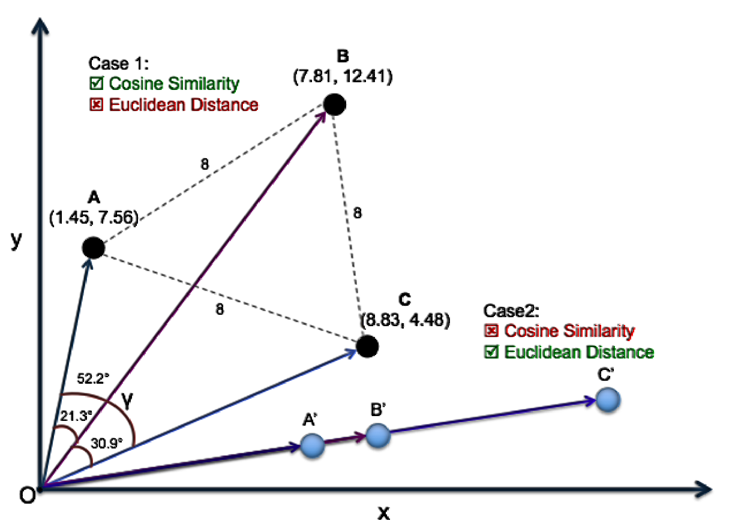

## CHAPTER 2: LITERATURE SURVEY



### Introduction

A Content-Based Recommender works by the data that we take from the user, either explicitly (rating) or implicitly (clicking on a link). By the data we create a user profile, which is then used to suggest to the user, as the user provides more input or take more actions on the recommendation, the engine becomes more accurate.

An elite scenario for modern recommendation systems is a Web application with which a user interacts. Typically, a system presents a summary list of items to a user, and the user selects among the items to receive more details on an item or to interact with the item in some way. For example, online news sites present web pages with headlines (and occasionally story summaries) and allow the user to select a headline to read a story. E-commerce sites often present a page with a list of individual products and then allow the user to see more details about a selected product and purchase the product.

Although the web server transmits HTML and the user sees a web page, the web server typically has a database of items and dynamically constructs web pages with a list of items. Because there are often many more items available in a database than would easily fit on a web page, it is necessary to select a subset of items to display to the user or to determine an order in which to display the items.

Content-based recommendation systems analyze item descriptions to identify items that are of particular interest to the user. Because the details of recommendation systems differ based on the representation of items, this chapter first discusses alternative item representations. The chapter concludes with a discussion of variants of the approaches.

### Related Work

Recommender System is defined as a decision-making strategy for users under complex information environments. Also, recommender system was defined from the perspective of E- commerce as a tool that helps users search through records of knowledge which is related to users’ interest and preference. Recommender system was defined as a means of assisting and augmenting the social process of using recommendations of others to make choices when there is no sufficient personal knowledge or experience of the alternatives. Recommender systems handle the problem of information overload that users normally encounter by providing them with personalized, exclusive content and service recommendations.

Recently, various approaches for building recommendation systems have been developed, which can utilize either collaborative filtering, content-based filtering or hybrid filtering. Collaborative filtering technique is the most mature and the most commonly implemented. Collaborative filtering recommends items by identifying other users with similar taste; it uses their opinion to recommend items to the active user. Collaborative recommender systems have been implemented in different application areas.

GroupLens is a news-based architecture which employed collaborative methods in assisting

users to locate articles from massive news database. Ringo is an online social information

filtering system that uses collaborative filtering to build users profile based on their ratings on music albums. Amazon uses topic diversification algorithms to improve its recommendation. The system uses collaborative filtering method to overcome scalability issue by generating a table of similar items offline through the use of item-to-item matrix. The system then recommends other products which are similar online according to the users’ purchase history. On the other hand, content-based techniques match content resources to user characteristics.

Content-based filtering techniques normally base their predictions on user’s information, and they ignore contributions from other users as with the case of collaborative techniques. Fab relies heavily on the ratings of different users in order to create a training set and it is an example of content-based recommender system. Some other systems that use content-based filtering to help users find information on the Internet include Letizia. The system makes use of a user interface that assists users in browsing the Internet; it is able to track the browsing pattern of a user to predict the pages that they may be interested in. Pazzani et al. designed an intelligent agent that attempts to predict which web pages will interest a user. The agent allows a user to provide training instances by rating different pages as either hot or cold. Jennings and Higuchi describe a model interests of a user in a Usenet news environment.

Despite the success of these two filtering techniques, several limitations have been identified. Some of the problems associated with content-based filtering techniques are limited content analysis, overspecialization and of data. Also, collaborative approaches exhibit cold-start, sparsity and scalability problems. These problems usually reduce the quality of recommendations. In order to mitigate some of the problems identified, Hybrid filtering, which combines two or more filtering techniques in different ways in order to increase the

accuracy and performance of recommender systems has been proposed. These techniques combine two or more filtering approaches in order to harness their strengths while leveling out their corresponding weaknesses. They can be classified based on their operations into weighted hybrid, mixed hybrid, switching hybrid, feature-combination hybrid, cascade hybrid, feature-augmented hybrid and meta-level hybrid.

Collaborative filtering and content-based filtering approaches are widely used today by implementing content-based and collaborative techniques differently and the results of their prediction later combined or adding the characteristics of content-based to collaborative filtering and vice versa. Finally, a general unified model which incorporates both content- based and collaborative filtering properties could be developed. The problem of sparsity of data and cold-start was addressed by combining the ratings, features and demographic information about items in a cascade hybrid recommendation technique in. In Ziegler et al. ,a hybrid collaborative filtering approach was proposed to exploit bulk taxonomic information designed for exacting product to address the data sparsity problem of CF recommendations, based on the generation of profiles via inference of super-topic score and topic diversification.

A hybrid recommendation technique is also proposed in Ghazantar and Pragel-Benett and this uses the content-based profile of individual user to find similar users which are used to make predictions. In Sarwar et al. collaborative filtering was combined with an information filtering agent. Here, the authors proposed a framework for integrating the content-based filtering agents and collaborative filtering. A hybrid recommender algorithm is employed by many applications as a result of new user problem of content-based filtering techniques and average user problem of collaborative filtering. A simple and straightforward method for combining

content-based and collaborative filtering was proposed by Cunningham et al. A music recommendation system which combined tagging information, play counts and social relations was proposed in Konstas et al. In order to determine the number of neighbors that can be automatically connected on a social platform, Lee and Brusilovsky embedded social information into collaborative filtering algorithm. A Bayesian mixed-effects model that integrates user ratings, user and item features in a single unified framework was proposed by Condiff et al.

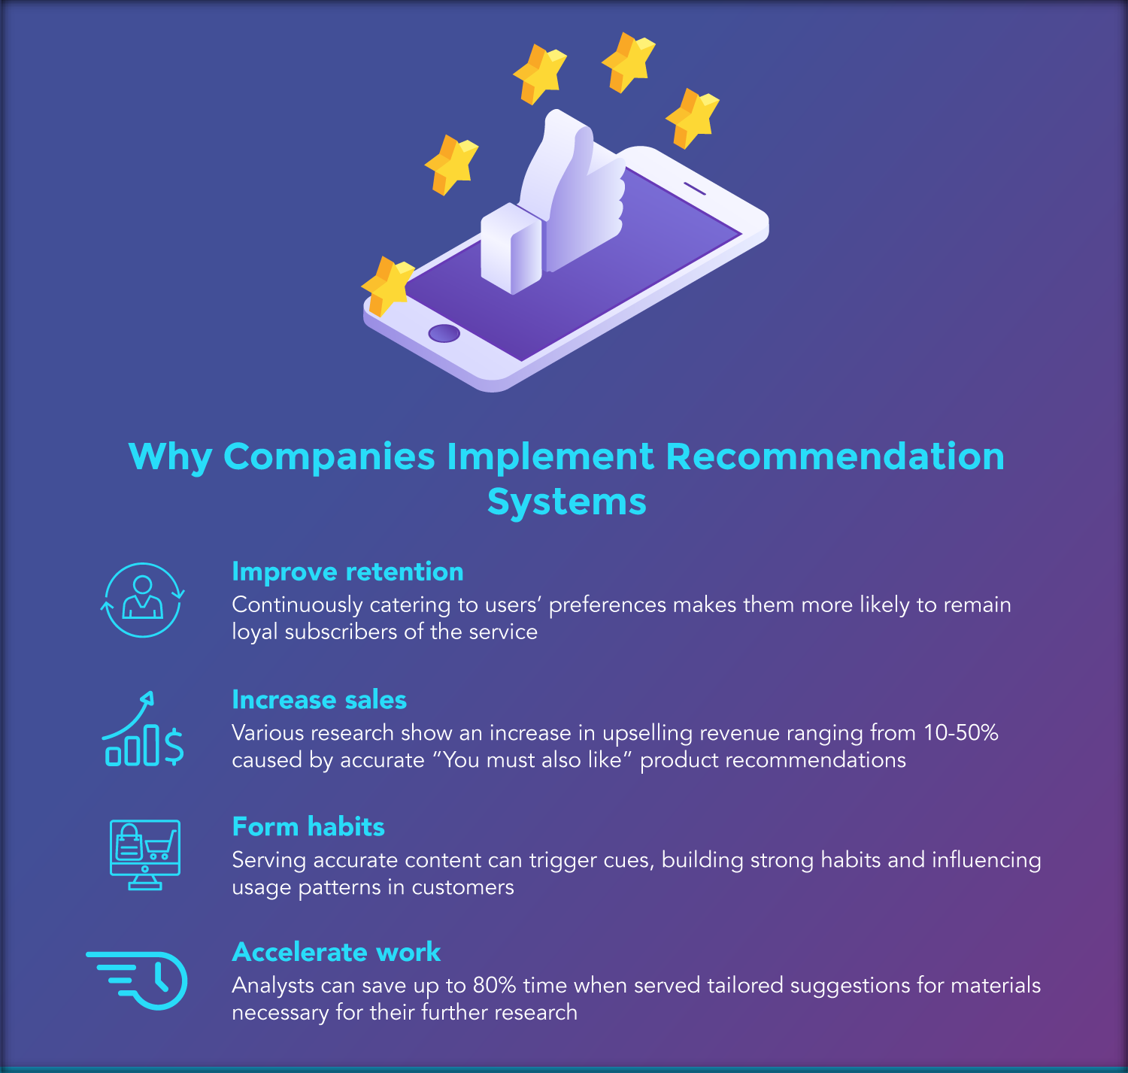

### Conclusion

There is already a substantial store of information that is becoming more and more readily accessible while at the same time growing at a healthy rate. Let’s take, for instance, a sample of the information a person can obtain about a favorite movie on the Web alone: a complete breakdown of cast/crew, plot, movie production details, reviews, trailer, film and audio clips, (and ratings too) and the list goes on. When users decide on a movie to see, they are likely to be influenced by data provided by one or more of these sources. Social-filtering may be characterized as a generic approach, unbiased by the regularities exhibited by properties associated with the items of interest. Indeed, a significant motivation for some the work on such systems is to explore the utility of recognizing communities of users based solely on similarities in their preferences. However, the fact that content-based properties can be identified at low cost (with no additional user effort and that people are influenced by these regularities make a compelling reason to investigate how best to use them.

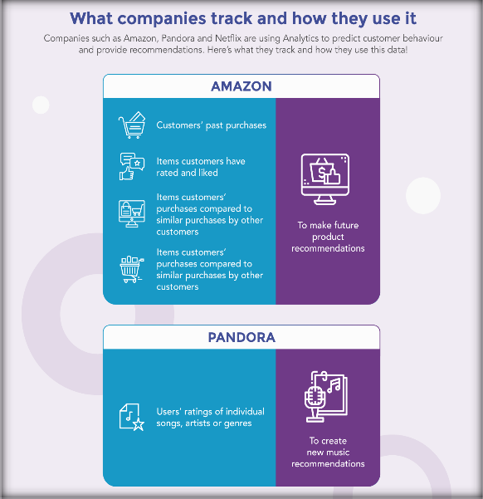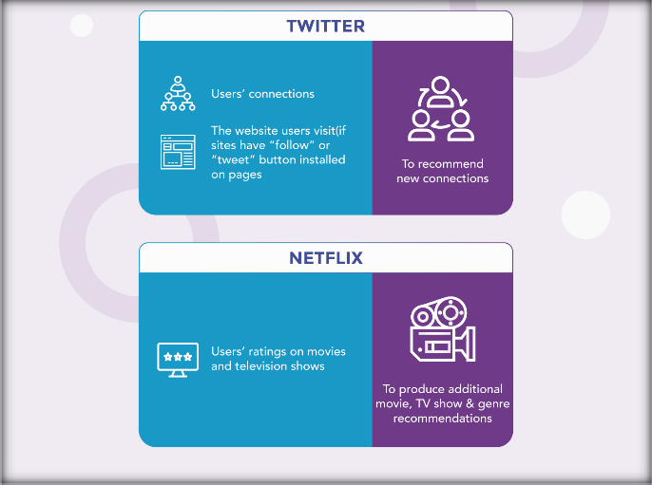

### CHAPTER 3: PROBLEM DESCRIPTION



* 1. **Problem Statement**
* Existing System is time consuming.
* Sometimes data present in dataset may be incorrect thus, leading to the incorrect information analysis.
* Limited training data leads to low accuracy.
* Data Analysis and cleaning isn’t performed well before training.
* Natural language processing isn’t done effectively on datasets.
* Lastly, it does not offer a user friendly UI.
* Euclidian distance is used when dealing with vectors.

The objective of this project is to do create a content-based Movie Recommender Systems and find a suitable way to deploy it as a web application. There are many kinds of Recommender Systems but not all of them are suitable for one specific problem and situation. Our objective is to find the most optimized method for classification of movies and finding similar movies on user input, which is the requirement of content-based recommender systems.

Three major parts in the project are:

* + Creating a recommendation system.
  + Build and test the web app for recommendation system using PyCharm IDE.
  + Deploy the web application using Heroku with proper APIs.

### Limitations of Existing system

Data Sparsity: In practice, many commercial recommender systems are based on large datasets. As a result, the user-item matrix used for collaborative filtering could be extremely large and sparse, which brings about the challenges in the performances of the recommendation. One typical problem caused by the data sparsity is the cold start problem. As collaborative filtering methods recommend items based on users’ past preferences, new users will need to rate sufficient number of items to enable the system to capture their preferences accurately and thus provides reliable recommendations. Similarly, new items also have the same problem. When new items are added to system, they need to be rated by substantial number of users before they could be recommended to users who have similar tastes with the ones rated them. The new item problem does not limit the content-based recommendation, because the recommendation of an item is based on its discrete set of descriptive qualities rather than its ratings.

Scalability: As the numbers of users and items grow, traditional CF algorithms will suffer serious scalability problems. For example, with tens of millions of customers and millions of items , a CF algorithm with the complexity of is already too large. As well, many systems need to react immediately to online requirements and make recommendations for all users regardless of their purchases and ratings history, which demands a higher scalability of a CF system. Large web companies such as Twitter use clusters of machines to scale

recommendations for their millions of users, with most computations happening in very large memory machines.

Cold Start Problem: The cold start problem is a typical problem in recommendation systems. The “cold start" problem happens in recommendation systems due to the lack of information, on users or items. The Cold-Start problem is a well known issue in recommendation systems: there is relatively little information about each user, which results in an inability to draw inferences to recommend items to users. The Cold start problem refers to the situation when a new user or item just enters the system. Three kinds of cold start problems are: new user problem, new item problem and new system problem. In such cases, it is really very difficult to provide recommendation as in case of new user, there is very less information about user that is available and also for a new item, no ratings are usually available and thus collaborative filtering cannot make useful recommendations in case of new item as well as new user. However, content based methods can provide recommendation in case of new item as they do not depends on any previous rating information of other users to recommend the item.

Privacy: Privacy is also a big issue in context of demographic recommender systems. In order to give the most accurate recommendation to the user, the system must acquire the most appropriate information of user, including demographic data (age, sex, email-id, hobbies etc.), and data about the location of a particular user which may breach the privacy of the user.

Over-Specialization: This is one of the most common problems faced by the content-based

recommendation system. A good recommender system must suggest diverse items which

content-based system lacks. It gives nothing “surprised”. It hinders the users from discovering something new and different. Users are recommended items they are already familiar with. Freshness (Predictability): One more problem generally faced by recommender systems these days is that of predictability. Even if the items recommended to the user are diverse, it might be familiar to the user. For example, a system recommends best sellers only. The recommendations in this case are indeed diverse but the user may already know or be familiar with the recommended stuff.

### Proposed Solution

Cold-Start: To curb the problem of cold-start, we can use the demographic information of the user from social networking sites or through the sign up page of the website. Also, we can use hybrid approach, i.e. to use collaborative filtering with demographic recommending approach to suggest items to a new user.

Sparsity: The problem of Sparsity can be resolved using hybrid recommendation technique. Instead of using content based alone we can combine the content based and collaborative technique together which will result as a solution of Sparsity. The amount of information people have in common can be increased by using the attributes of an item instead of the item itself.

Overspecialization: The problem of overspecialization can be overcome with the neighborhood based collaborative filtering technique. For the probabilistic neighborhood selection phase, we use a method for weighted sampling of k neighbors that takes into consideration the similarity levels between the user/items and candidate neighbors.

## CHAPTER 4: METHODOLOGY



### System Specifications

#### Following are the list of system requirements/base for building, testing and deploying our project.

Software Specifications:

|  |  |
| --- | --- |
| **OPERATING SYSTEM** | **Windows 8,8.1 and above** |
| **SOFTWARES** | * Anaconda3 2021.11 (Jupyter Notebook) * Python 3.9.7 (64-bit) * Git 2.36.0 * PyCharm Community Edition 221.5080 * Heroku 7.53.0 |

Hardware Specifications:

|  |  |
| --- | --- |
| **PROCESSOSR TYPE** | Intel Core i3 or above for optimum performance |
| **SYSTEM RAM** | 3.00GB or above |
| **INPUT DEVICE** | Basic Keyboard and Touchpad |
| **OUTPUT DVICE** | Standard Color Monitor |

## Initial Overview

What is a recommender system?

A recommender system is a simple algorithm whose aim is to provide the most relevant information to a user by discovering patterns in a dataset. The algorithm rates the items and shows the user the items that they would rate highly. An example of recommendation in action is when you visit Amazon and you notice that some items are being recommended to you or when Netflix recommends certain movies to you. They are also used by Music streaming applications such as Spotify and Deezer to recommend music that you might like.

Below is a very simple illustration of how recommender systems work in the context of an e- commerce site.

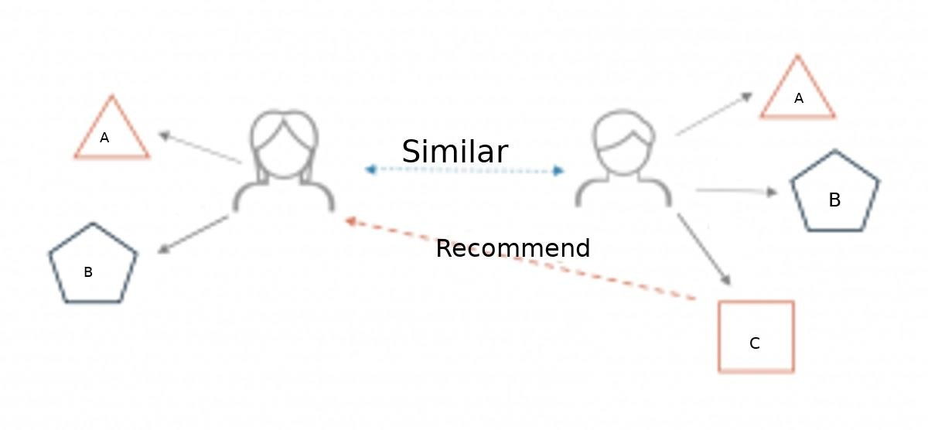

Two users buy the same items A and B from an e-commerce store. When this happens the similarity index of these two users is computed. Depending on the score the system can recommend item C to the other user because it detects that those two users are similar in terms of the items they purchase.

Different types of recommendation engines

The most common types of recommendation systems are **content-based** and **collaborative filtering** recommender systems. In collaborative filtering, the behavior of a group of users is used to make recommendations to other users. The recommendation is based on the preference of other users. A simple example would be recommending a movie to a user based on the fact that their friend liked the movie.

**Content Based Recommendation Engine:**

A Content-Based Recommender works by the data that we take from the user, either explicitly (rating) or implicitly (clicking on a link). By the data we create a user profile, which is then used to suggest to the user, as the user provides more input or take more actions on the recommendation, the engine becomes more accurate.

It uses metadata such as genre, producer, actor, musician to recommend items say movies or music. Content-based systems are based on the idea that if you like a certain item you are most likely to like something that is similar to it.

**Collaborative Filtering Recommendation Engine:**

There are two types of collaborative models **Memory-based** methods and **Model- based** methods. The advantage of memory-based techniques is that they are simple to implement and the resulting recommendations are often easy to explain. They are divided into two:

* **User-based collaborative filtering**: In this model, products are recommended to a user based on the fact that the products have been liked by users similar to the user. For example, if Rishabh and Ritvik like the same movies and a new movie come out that Rishabh like, then we can recommend that movie to Ritvik because Rishabh and Ritvik seem to like the same movies.
* **Item-based collaborative filtering**: These systems identify similar items based on users’ previous ratings. For example, if users A, B, and C gave a 5-star rating to books X and Y then when a user D buys book Y they also get a recommendation to purchase book X because the system identifies book X and Y as similar based on the ratings of users A, B, and C.

Model-based methods are based on Matrix Factorization and are better at dealing with sparsity. They are developed using data mining, machine learning algorithms to predict users’ rating of unrated items. In this approach techniques such as dimensionality reduction are used to improve accuracy. Examples of such model-based methods include Decision trees, Rule-based Model, Bayesian Model, and latent factor models.

**4.2 Analysis**

The backend will consist of the following inputs and procedures:

* Datsets information
* Data Extraction (Text Extraction)
* Data Analysis
* Data Cleaning
* Data Export via dump ()
* Natural Language processing
* Data trimming and merging
* Calculation of relation between data

The Code will also consist of the following functions/ Libraries/ and Methods:

* + Numpy
  + Pandas
  + Ast
  + Nltk
  + Sklearn
  + Count Vectorizer
  + Cosine Similarity
  + Pickle
  + Stramlit
  + Requests
  + Shape, Head() etc.
  + Literal_eval

Outputs of software will include:

* + User friendly User Interface.
  + Movie List Generation.
  + Recommnedations Generated on the basis of entered item.
  + Latest Poster generation.

**CHAPTER 5: IMPLEMENTATION**



# Datasets to use for building recommender systems

In this project, we are going to use the TMDB 5000 Movie Dataset***.***

This dataset was generated from API. This product uses the TMDb API but is not endorsed or certified by TMDb. Their API also provides access to data on many additional movies, actors and actresses, crew members, and TV shows.

# Walkthrough of building a recommender system

#### We are going to use the movie data to build a content-based recommender system. The first thing we need to do is to import pandas and numpy.

import pandas as pd import numpy as np

Next, we load in the data sets using pandas read_csv() utility. movies=pd.read_csv('tmdb_5000_movies.csv') credits=pd.read_csv('tmdb_5000_credits.csv')

#### Now let’s check the head of both the datasets (movies.csv & credits.csv) to see the data we are dealing with.

credits.head(1) credits.head(1)

#### Now merge both the datasets (movies.csv & credits.csv) by the common column ‘title’ to see the data we are dealing with:

movies=movies.merge(credits,on='title')

#### Now we truncate the columns from our merged data frame that we don’t need to create tags.

movies=movies[['movie_id','title','overview','genres','keywords','cast','crew']] movies.head()

Let’s look at what each column represents:

* movie_id - the IMDB ID of the movie.
* title- the title of the movie.
* overview - The summary of the movie.
* genres - The genres of the movie (can be more than one).
* keywords- The discription of the movie.

#### Now checking for Null values in our data frame and removing them to increase the efficiency (cleaning the data).

movies.isnull().sum()

movies.dropna(inplace=True)

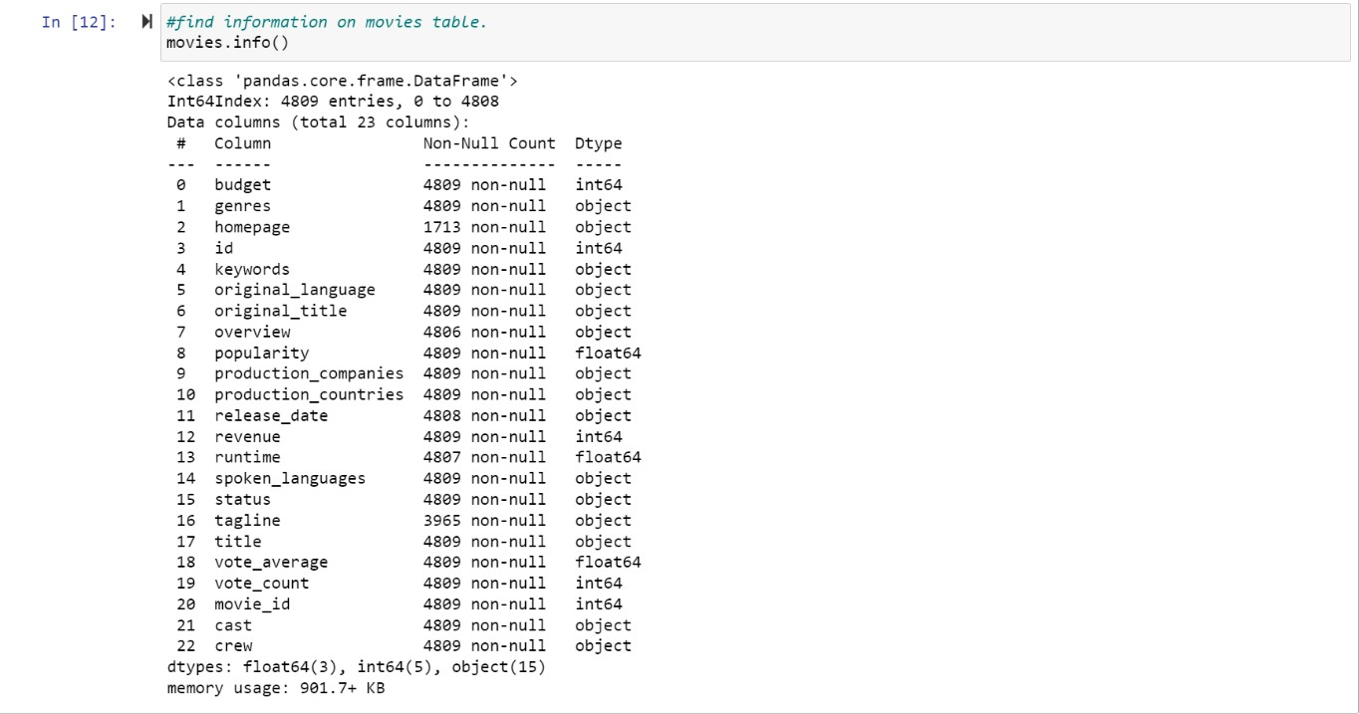

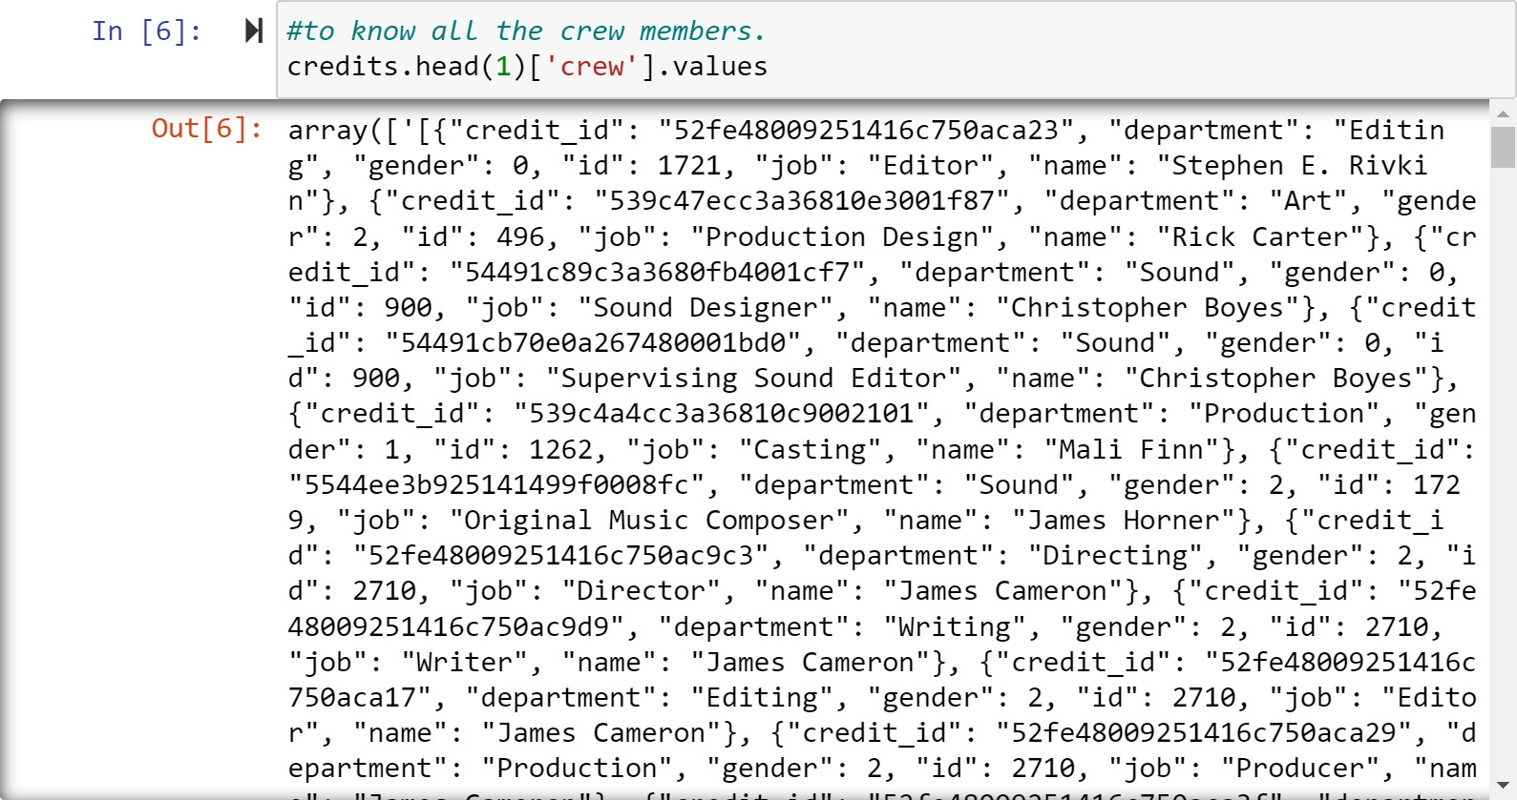

#### Now, we will create tags for each movie. A new tags column will contain the

keywords unique to the movie like name of the movie, it’s cast, it’s crew(director), summary, genre etc. Now to do this we will fetch genre from our genre column using ast.literal_eval method as it will fetch us list from the string where we can perform our functions to fetch genre.

def convert(obj): my_list=[]

for i in ast.literal_eval(obj): my_list.append(i['name'])

return my_list movies['genres']=movies['genres'].apply(convert)

#### Next we would perform similar operations on the ‘cast’ & ‘crew’ columns. We will fetch first three actor names from each movie and directors name of that movie:

def convert3(obj): my_list=[] counter=0

for i in ast.literal_eval(obj): if counter!=3:

my_list.append(i['name']) counter+=1

else:

break return my_list

movies['cast']=movies['cast'].apply(convert3)

def fetch_director(obj):

my_list=[]

for i in ast.literal_eval(obj): if i['job']=='Director':

my_list.append(i['name']) break

return my_list movies['crew']=movies['crew'].apply(fetch_director)

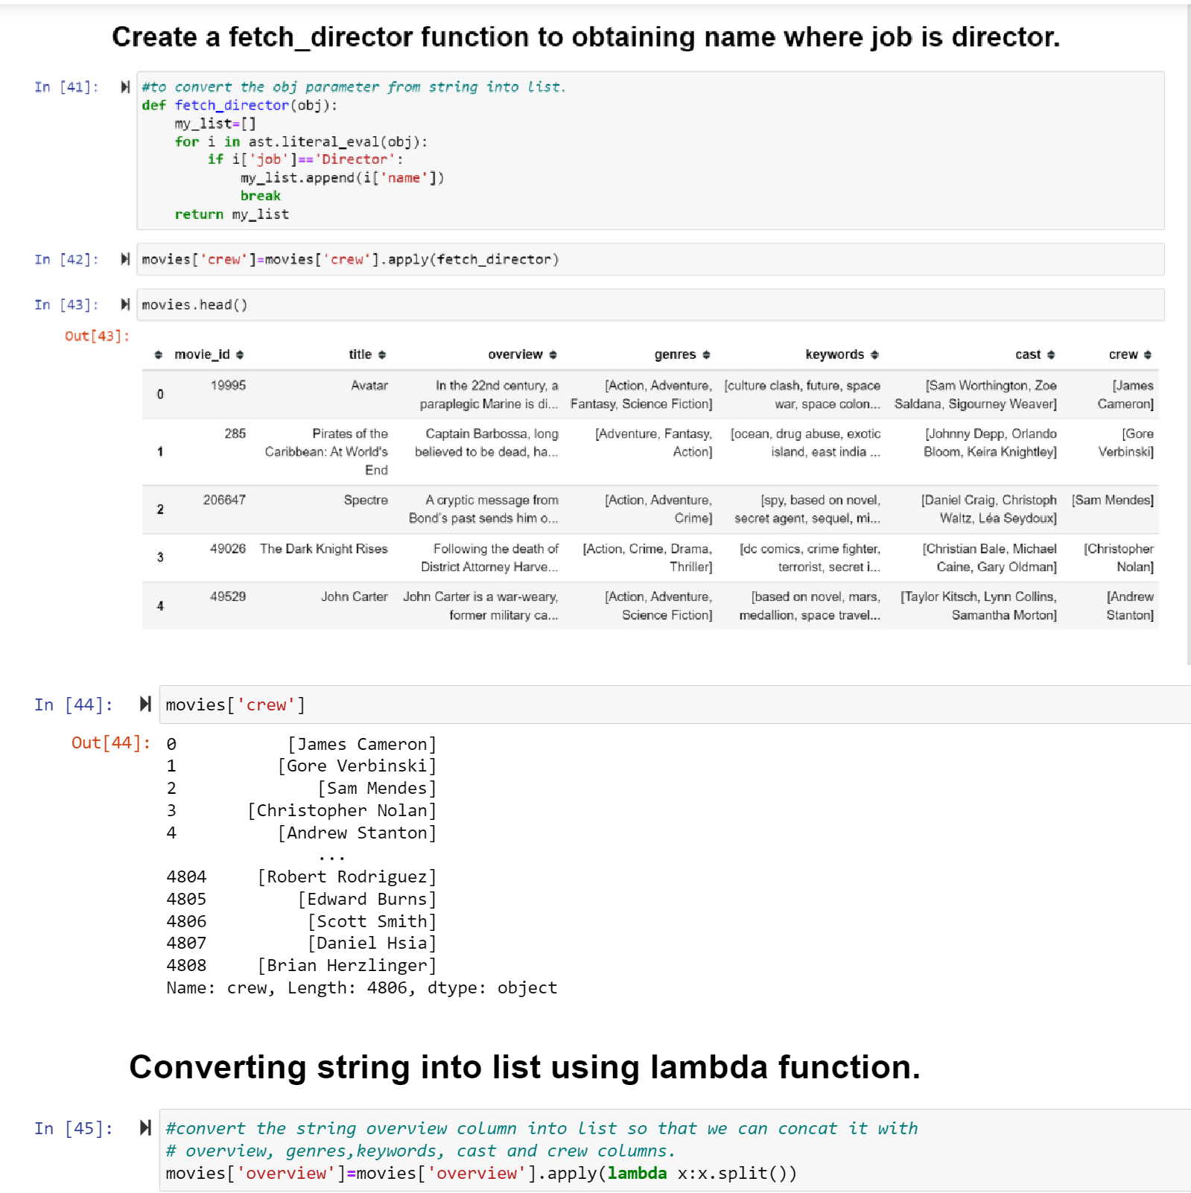

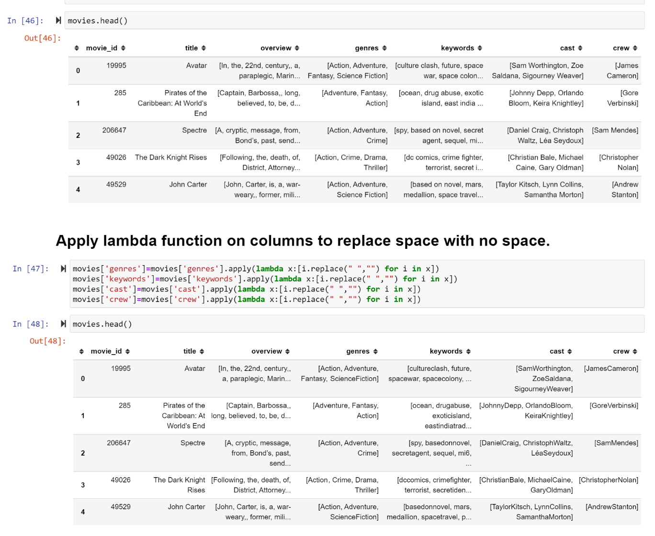

#### Now we convert all the columns into list from string format and combine them into one new column ‘tags’:

movies['genres']=movies['genres'].apply(lambda x:[i.replace(" ","") for i in x]) movies['keywords']=movies['keywords'].apply(lambda x:[i.replace(" ","") for i in x]) movies['cast']=movies['cast'].apply(lambda x:[i.replace(" ","") for i in x])

movies['crew']=movies['crew'].apply(lambda x:[i.replace(" ","") for i in x])

movies['tags']=movies['overview']+movies['genres']+movies['keywords']+movies['cast']+mo vies['crew']

#### Now our new data frame has only three columns: ‘Id’, ‘title’, ‘tags’. Convert the ‘tags’ column from list to string and then we perform stemming. Stemming is the process of reducing inflected (or sometimes derived) words to their word stem, base or root form. For this we import Natural language toolkit:

import nltk

from nltk.stem.porter import PorterStemmer ps=PorterStemmer()

#### After performing stemming, we have reduced the words in tags for each movie as root word is only retained. For Example: All the words like looking, looked, looks are reduced to only single root word ‘look’. Hence it is done for all the words present in tags column, thereby increasing efficiency of our prediction.

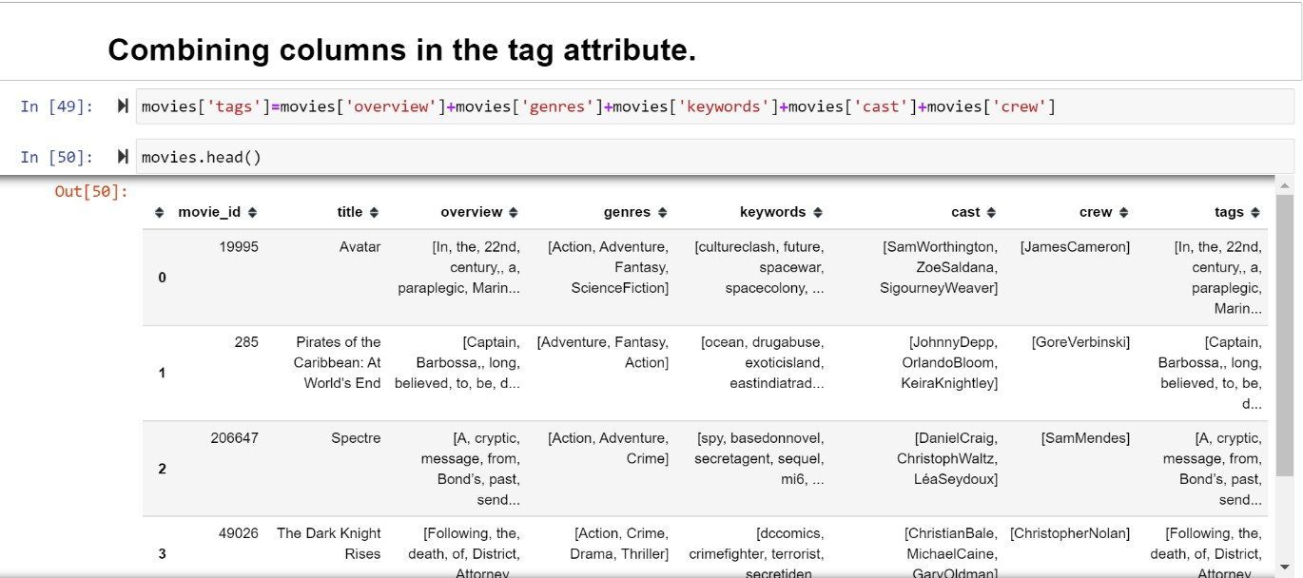

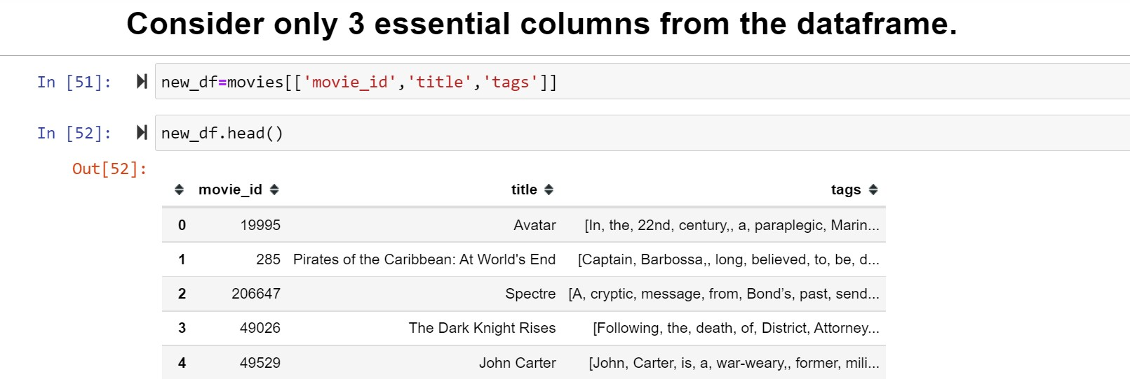

def stem(text): y=[]

for i in text.split(): #convert to list from string. y.append(ps.stem(i)) #use to perform stem function

return ' '.join(y) #convert into string from list.

#### Now we perform Vectorization of our text data. This is done by class called CountVectorizer that is available in scikit-learn library. Vectorization is performed on only 5000 words out of all the words available in the ‘tags’ column. Top 5000 words that are repeated the most minus the stop words in the English language.

from sklearn.feature_extraction.text import CountVectorizer cv=CountVectorizer(max_features=5000,stop_words='english') vectors=cv.fit_transform(new_df['tags']).toarray()

#### After the vertorization is completed, we have one vector representing one movie in the 5000 dimensional space (as 5000 words are features), Now to find a similar movie we have to look for the closest vector of our given vector. This can be done by cosine_similarity function that is available in scikit-learn library. This function will calculate cosine angle of every movie with every other movie in the dataset.

from sklearn.metrics.pairwise import cosine_similarity similarity=cosine_similarity(vectors)

After calculating these distances we sort the distances for each movie with each movie using sort function and use enumerate function to hold the distance of each movie with a particular movie in a index. sorted(list(enumerate(similarity[0])),reverse=True,key=lambda x:x[1])

#### Finally, we will create a Recommend function whom we will feed a movie name and it will fetch and return 5 similar movies for us:

def recommend(movie): movie_index=new_df[new_df['title']==movie].index[0] distances=similarity[movie_index]

movies_list=sorted(list(enumerate(distances)),reverse=True,key=lambda x:x[1])[1:6]

for i in movies_list:

print(new_df.iloc[i[0]].title)

#### Now, We have to develop this program on website, for that we create a new file in Pycharm IDE and import the movies list to be displayed on our website from which user can select. This can be done by using Pickle library, to create a dump of our current data frame and export the titles of our movies to the PyCharm file.

import pickle pickle.dump(new_df.to_dict(),open('movie_dict.pkl','wb'))

#### Similarly, we also export ‘similarity’ column which contains the cosine-distance for each movie as it will be used to suggest the similar movies:

pickle.dump(similarity,open('similarity.pkl','wb'))

#### We import these dumps in PyCharm IDE by using pickle tool:

movies_dict = pickle.load(open('movie_dict.pkl','rb')) movies = pd.DataFrame(movies_dict)

similarity = pickle.load(open('similarity.pkl', 'rb'))

#### In PyCharm File, we use streamlit library to create a web app as it is compatible with major Python libraries such as scikit-learn, Keras, PyTorch, SymPy(latex), NumPy, pandas, Matplotlib etc.

import streamlit as st

#### Now, we create Recommend function which will take the input and calculate top

5 movies that should be displayed and also fetch there posters by using ‘fetch_poster’ function which uses APIs to get movie poster from themoviedb.org by their Ids.

def fetch_poster(movie_id): response=requests.get('https://api.themoviedb.org/3/movie/{}?api_key=1a219482c51 e5dc798ae1ac0a309d459&language=en-US'.format(movie_id))

data = response.json()

return "https://image.tmdb.org/t/p/w500/" + data['poster_path']

def recommend(movie):

movie_index = movies[movies['title'] == movie].index[0] distances = similarity[movie_index]

movies_list = sorted(list(enumerate(distances)), reverse=True, key=lambda x: x[1])[1:6] recommended_movies=[]

recommended_movies_posters=[]

for i in movies_list:

movie_id = movies.iloc[i[0]].movie_id recommended_movies.append(movies.iloc[i[0]].title) #fetch poster from api

recommended_movies_posters.append(fetch_poster(movie_id)) return recommended_movies, recommended_movies_posters

#### We use Heroku for the deployment of our web-app, Heroku is a container-based cloud Platform as a Service (PaaS). Developers use Heroku to deploy, manage, and scale modern apps.

It enables us to build, run, and operate applications entirely in the cloud.

#### For this, we create three files:

* Proc File

#### Setup.sh

* .gitignore

#### ProcFile will contain the commands that has to be executed by the Heroku while deploying on cloud.

Setup.sh contains the directories for our server setup.

#### .gitignore file contains our virtual environment folder as it should not be uploaded to the cloud.

Pip freeze > requirements.txt

Above command when run gives the libraries used as they have to be mentioned as well.

**CHAPTER 6: OUTPUT**



#### Outputs from jupyter notebook

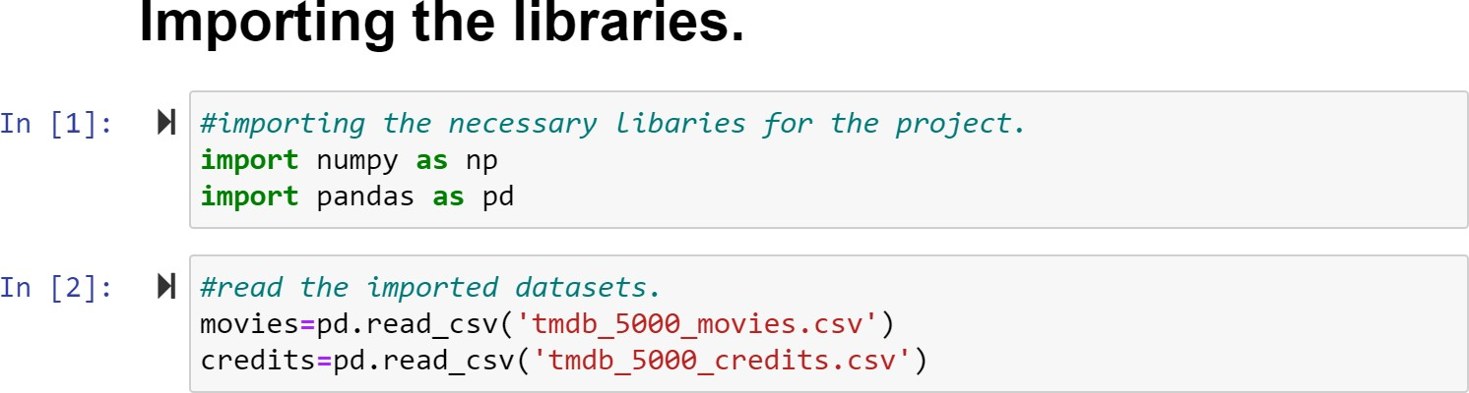

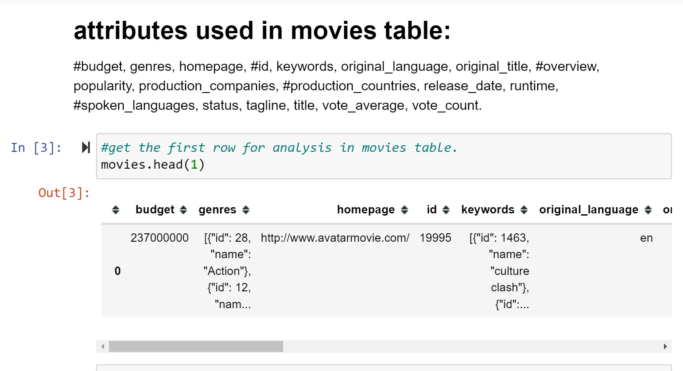

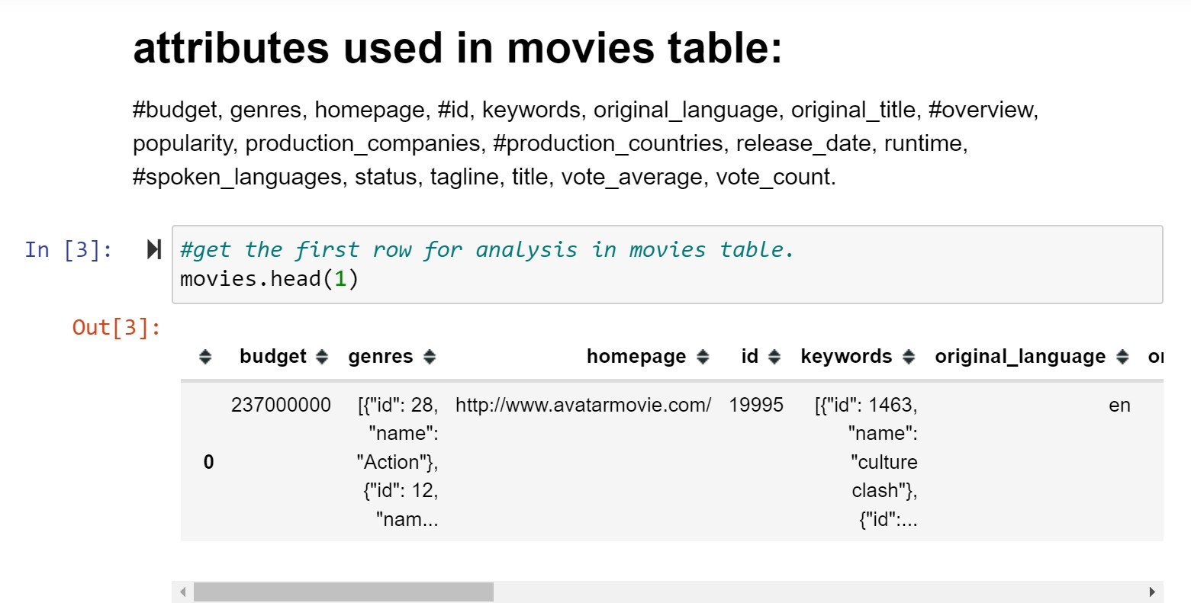

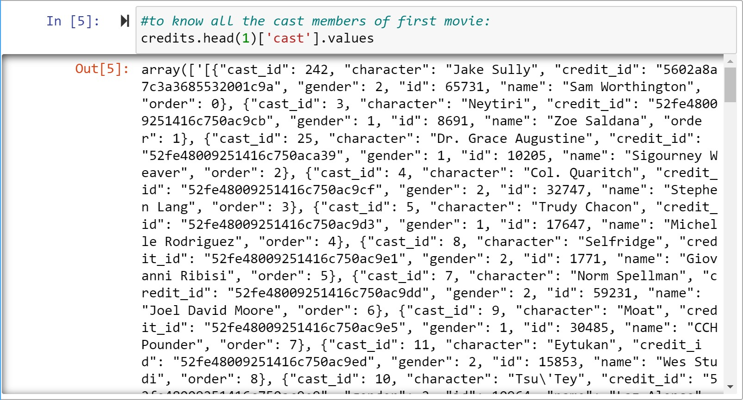



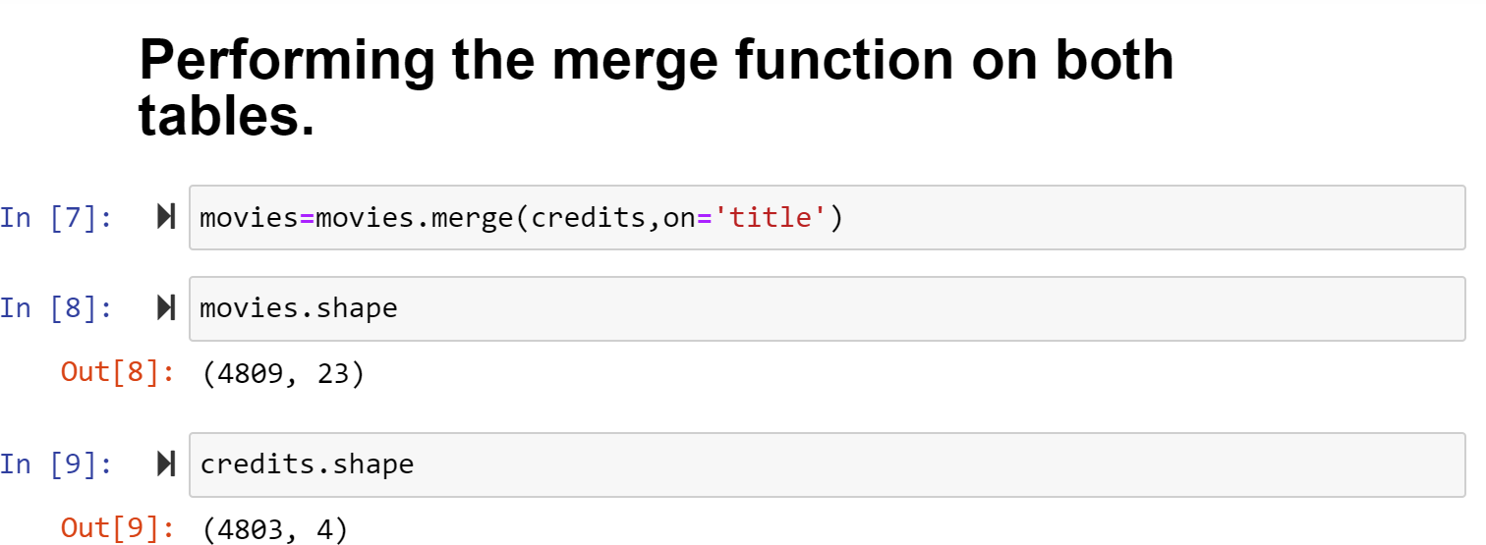

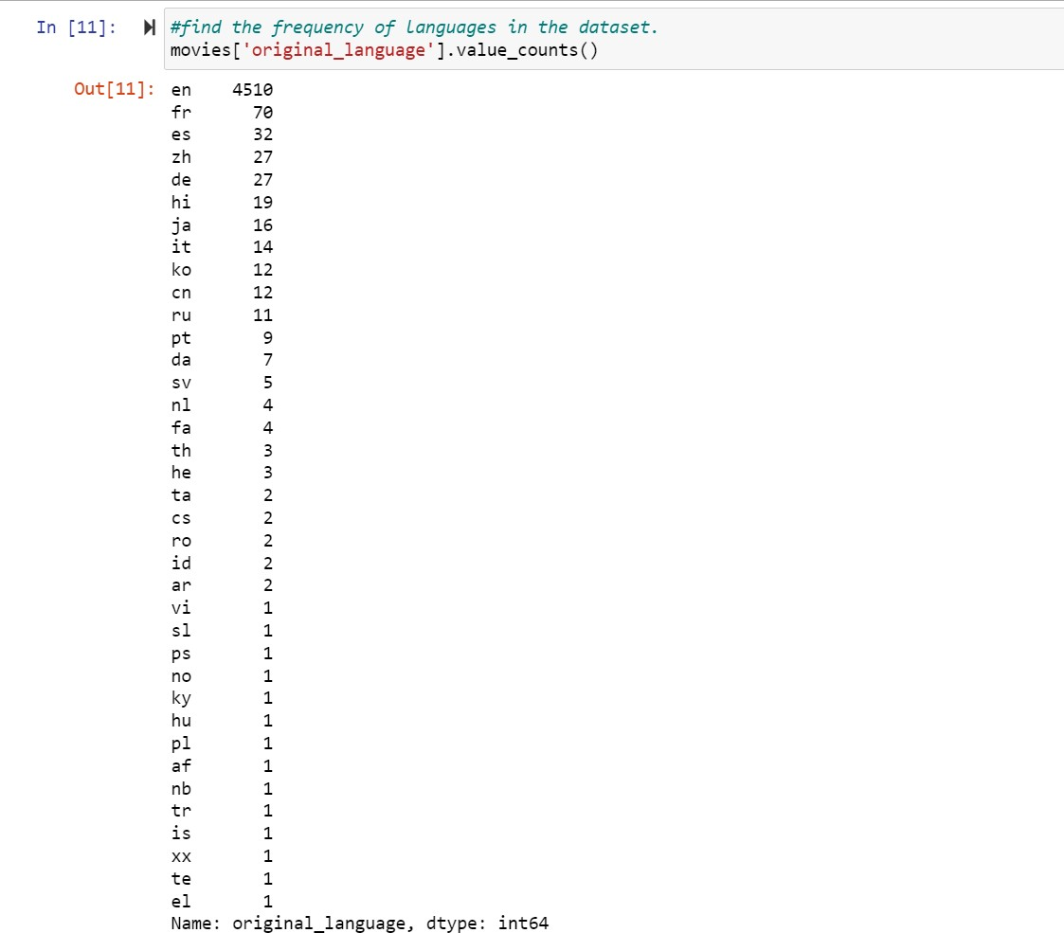

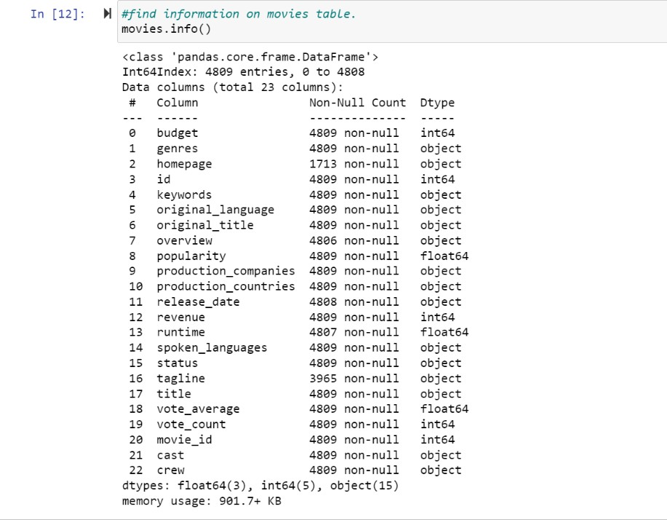

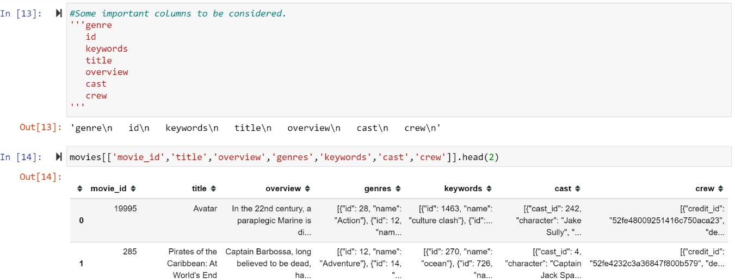



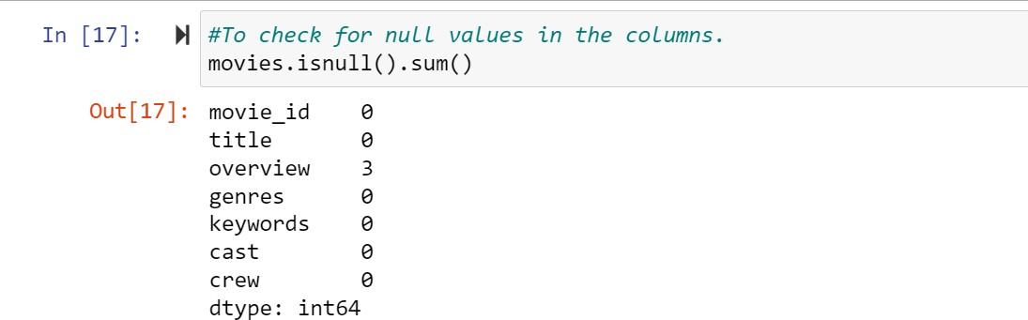

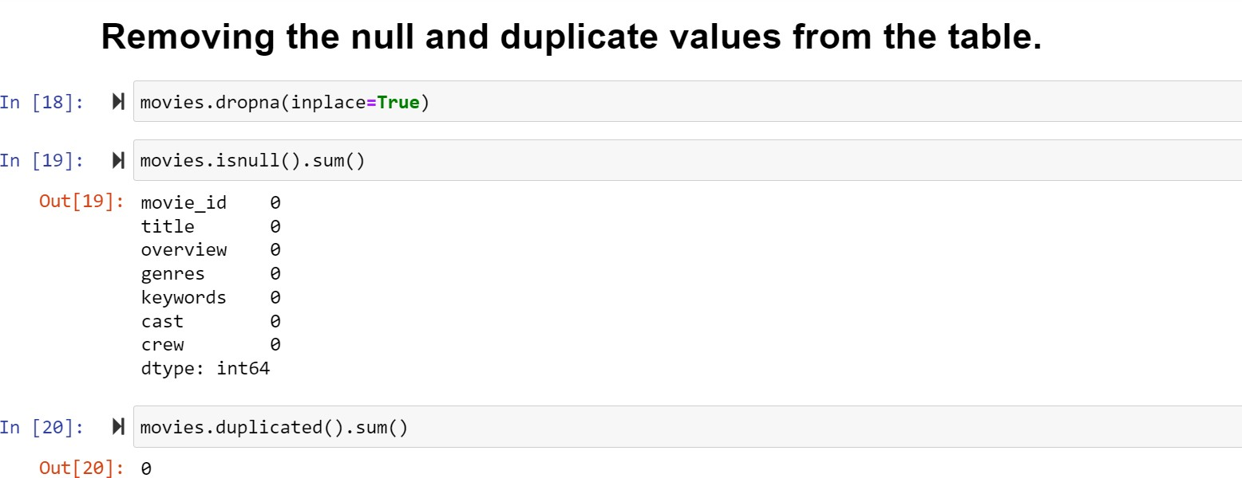

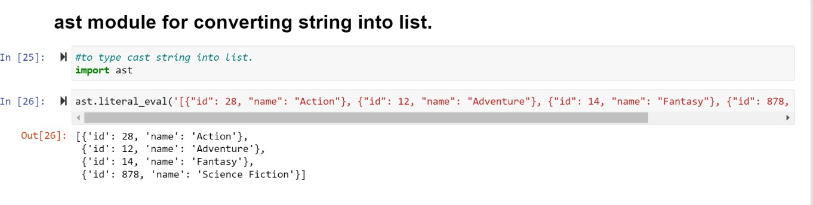

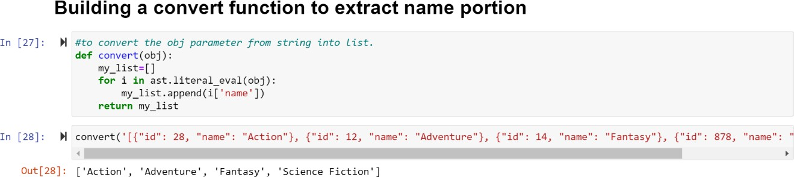

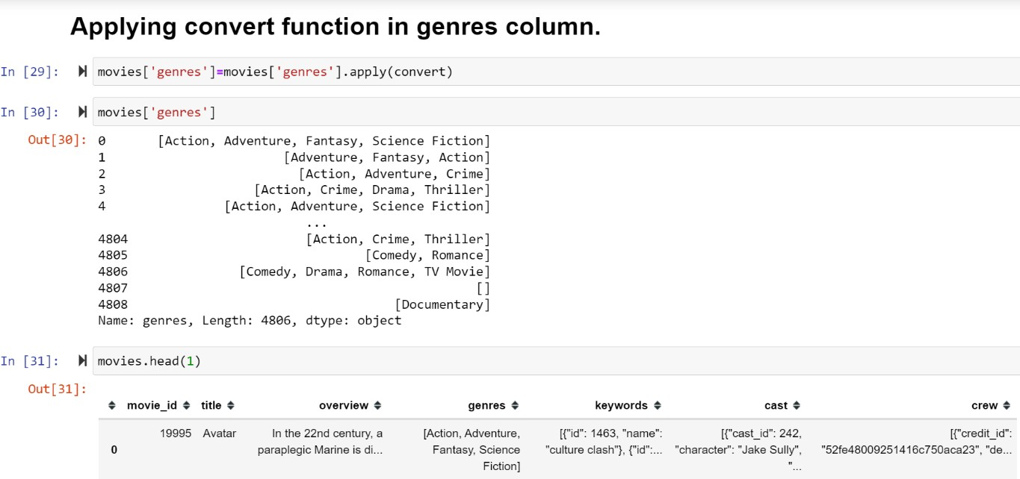

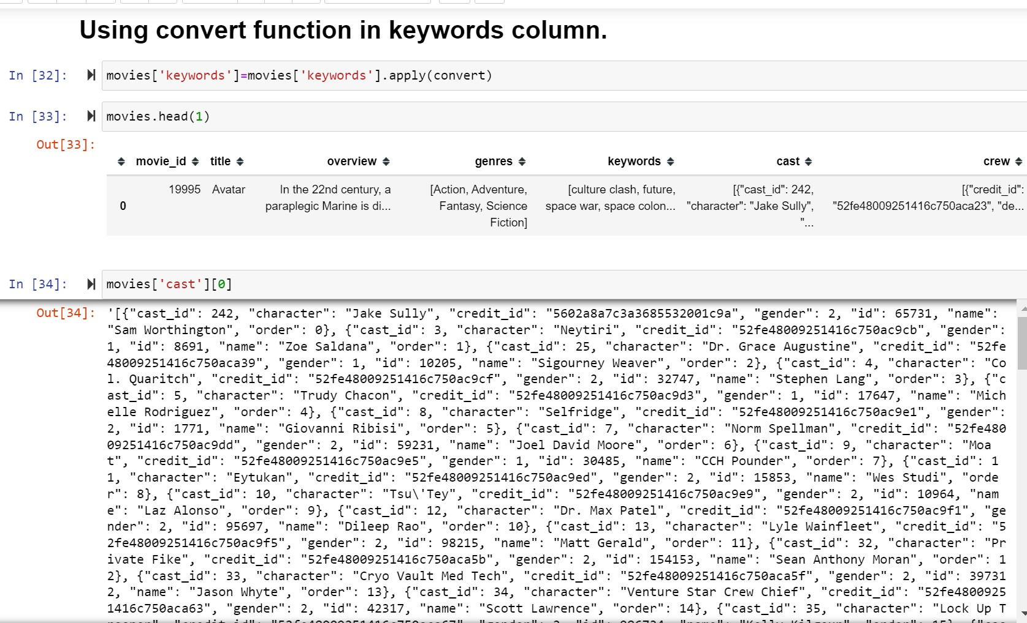

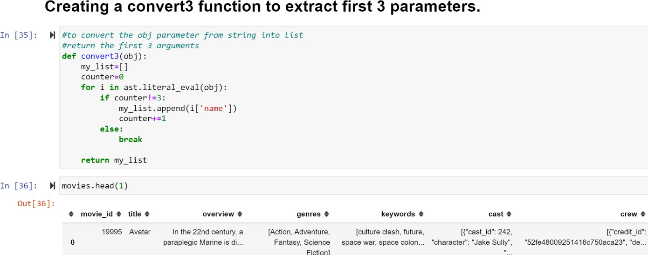

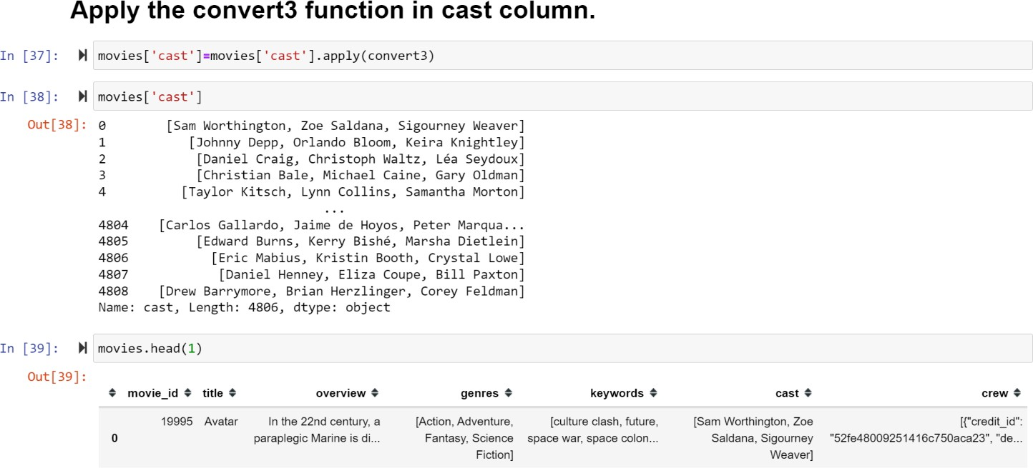

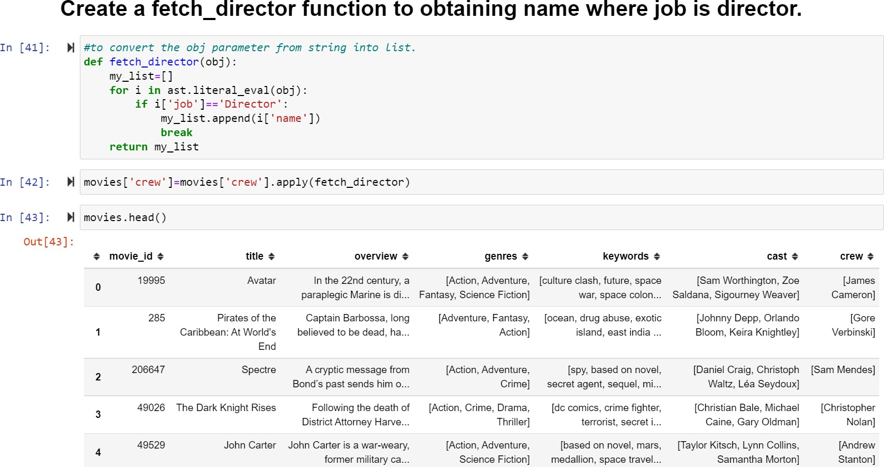

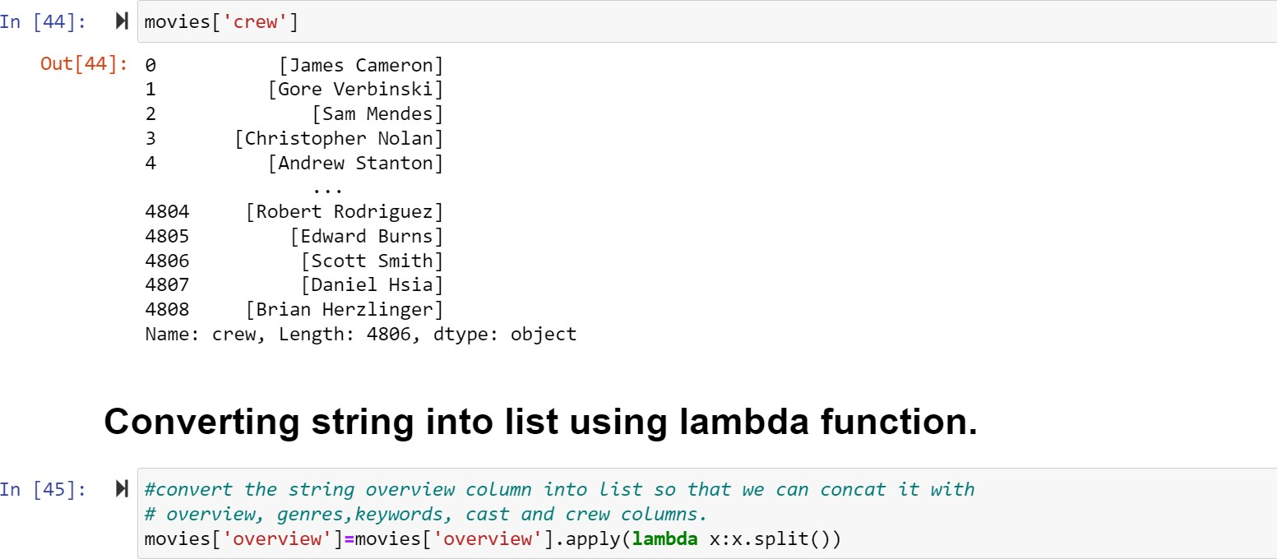

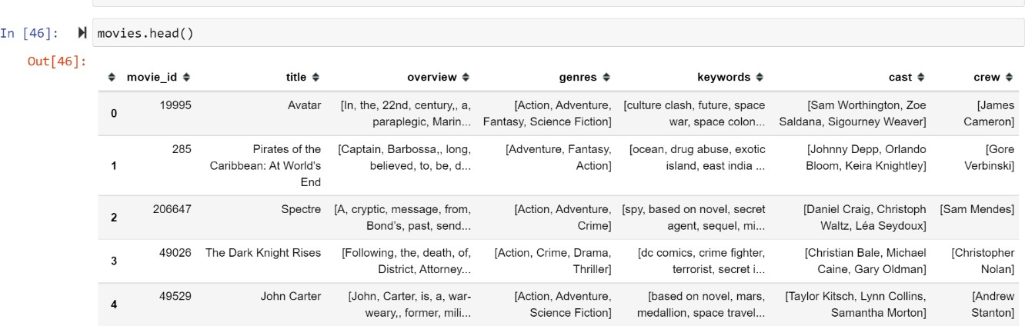

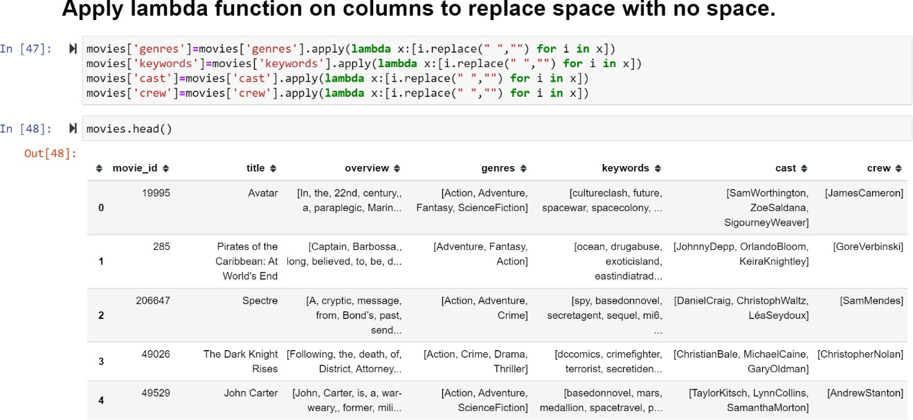





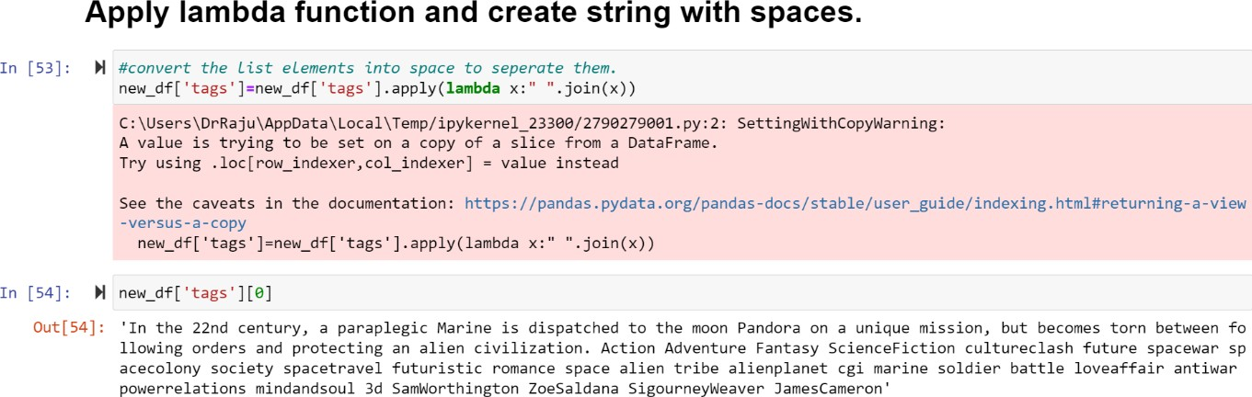

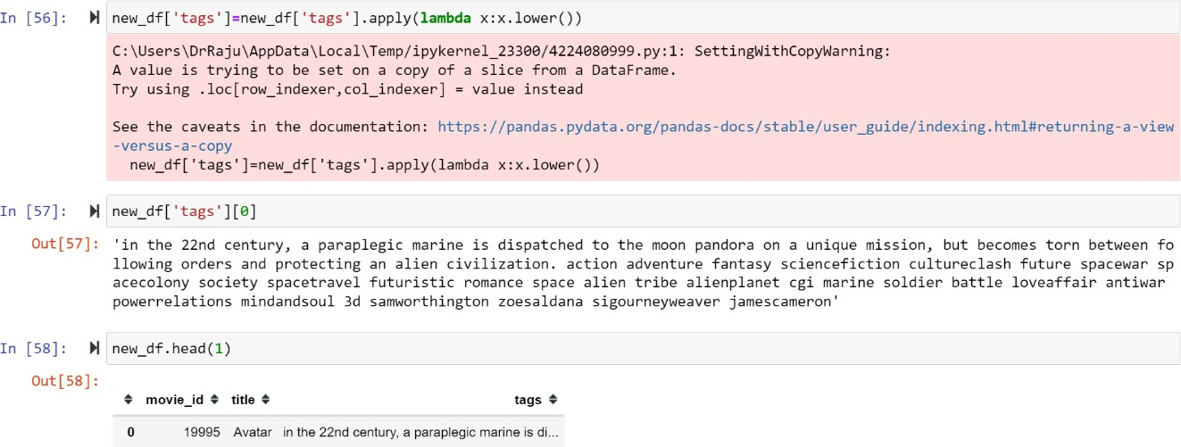

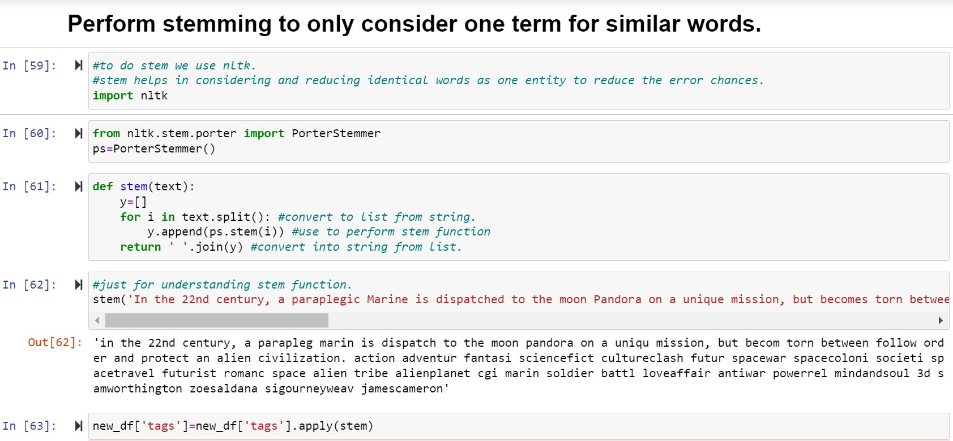

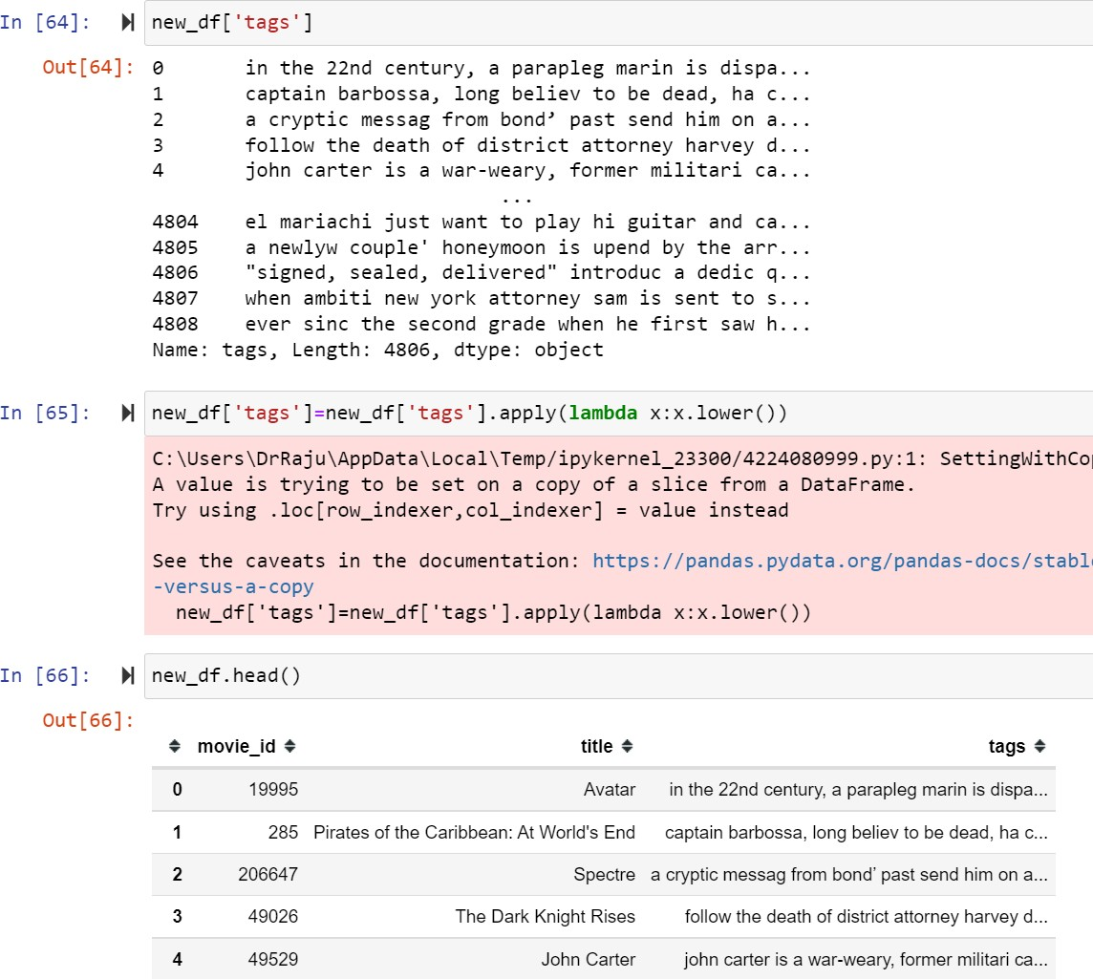

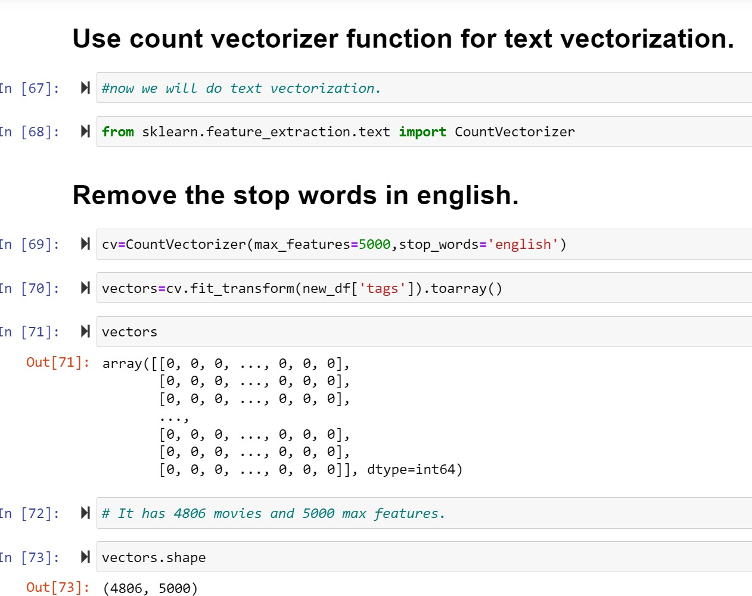

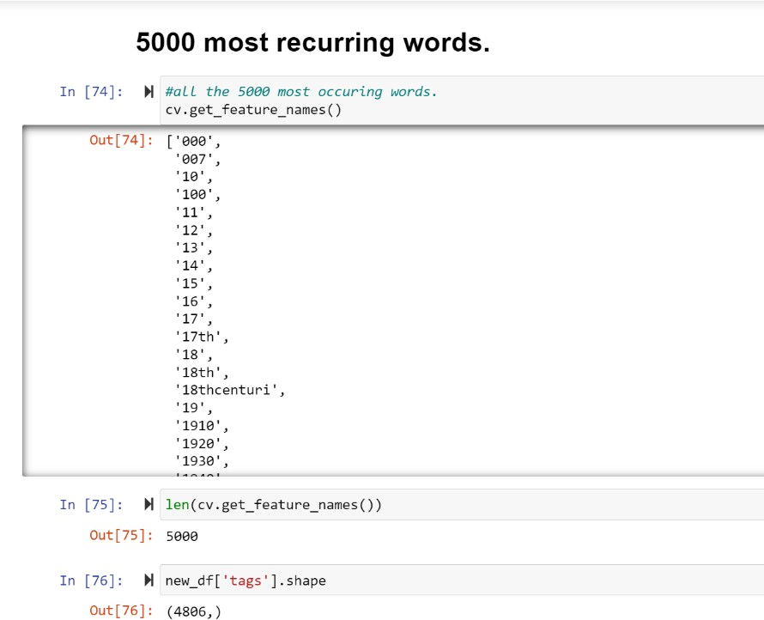

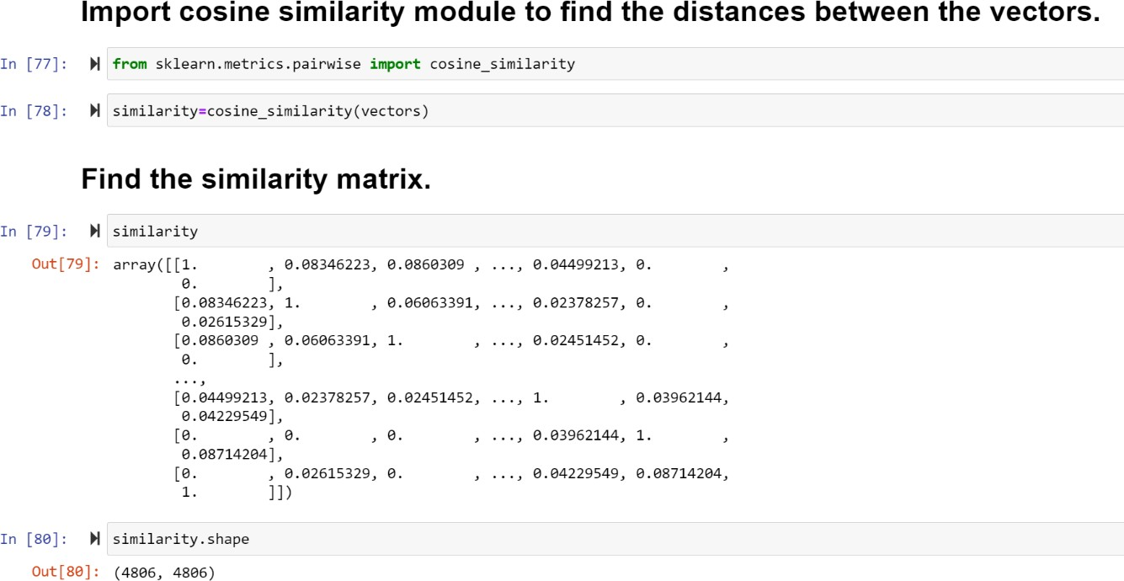

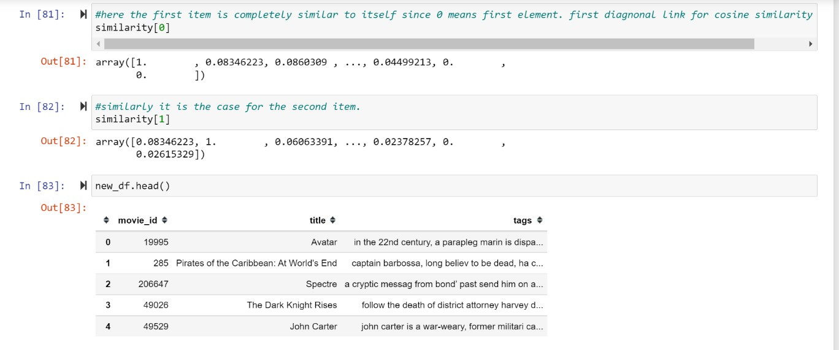

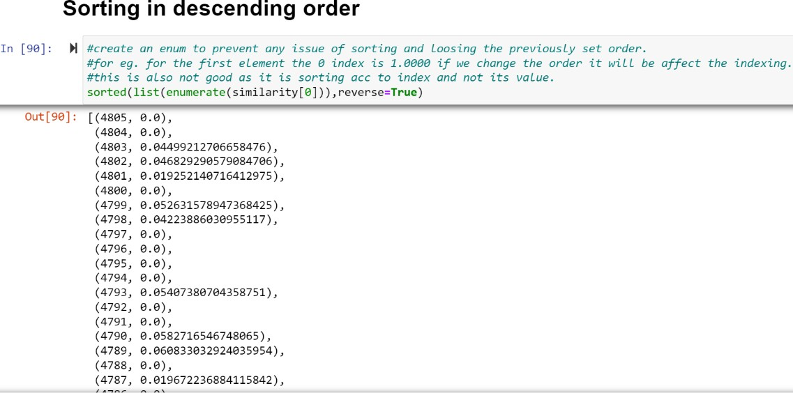

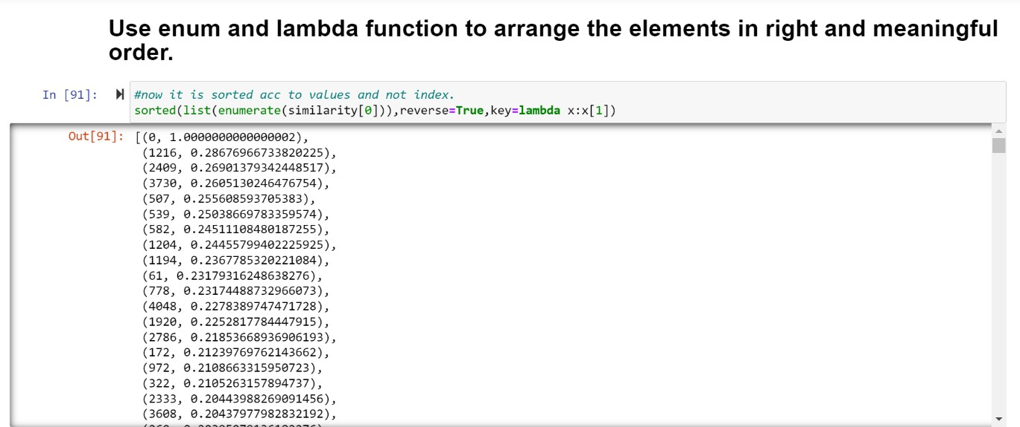

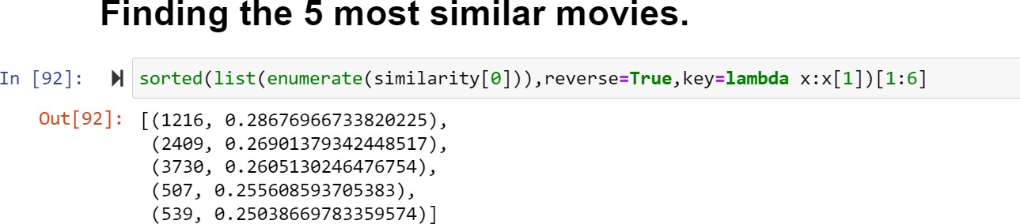

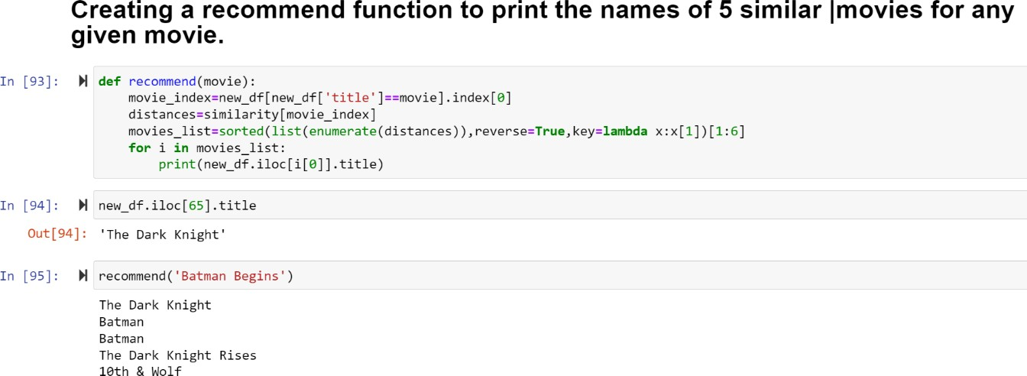

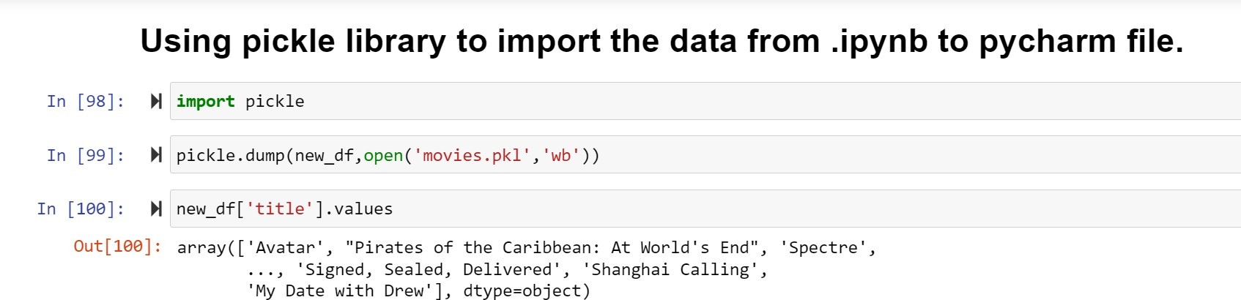

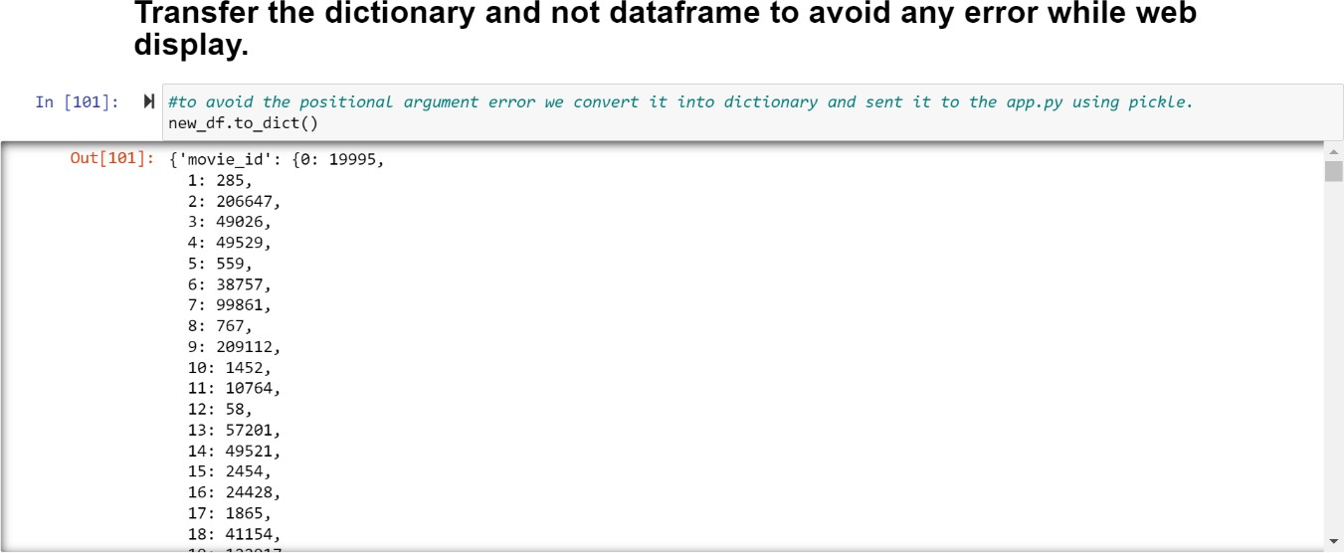

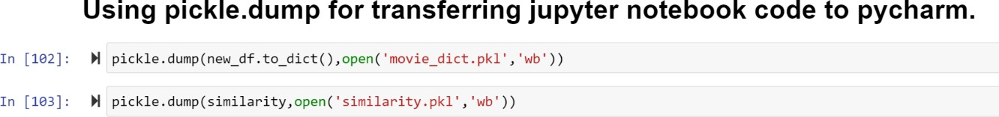

* 1. Output of Building &Designing in PyCharm.

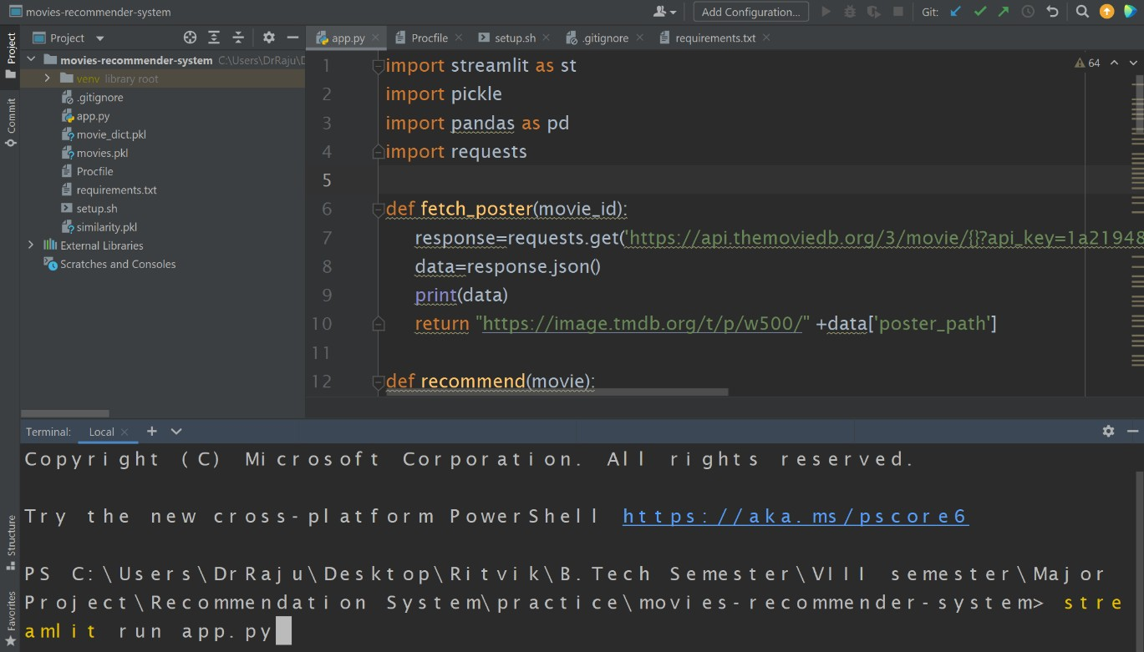

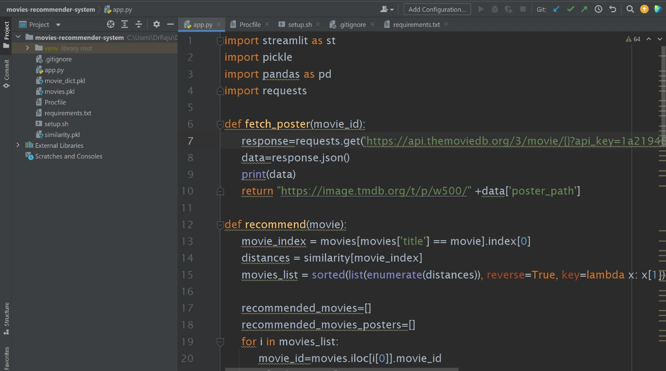

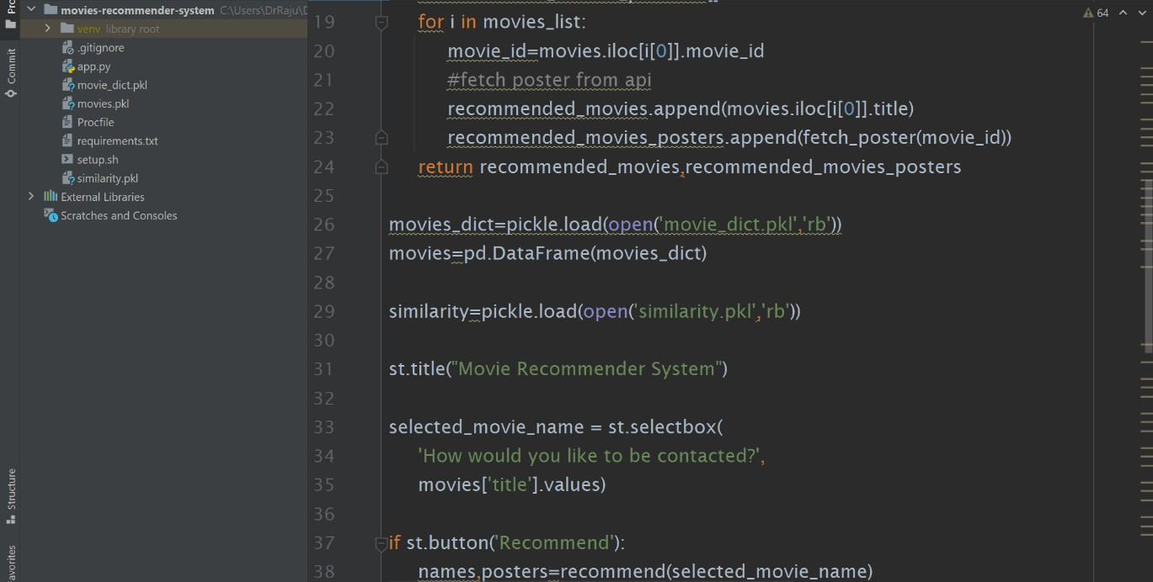

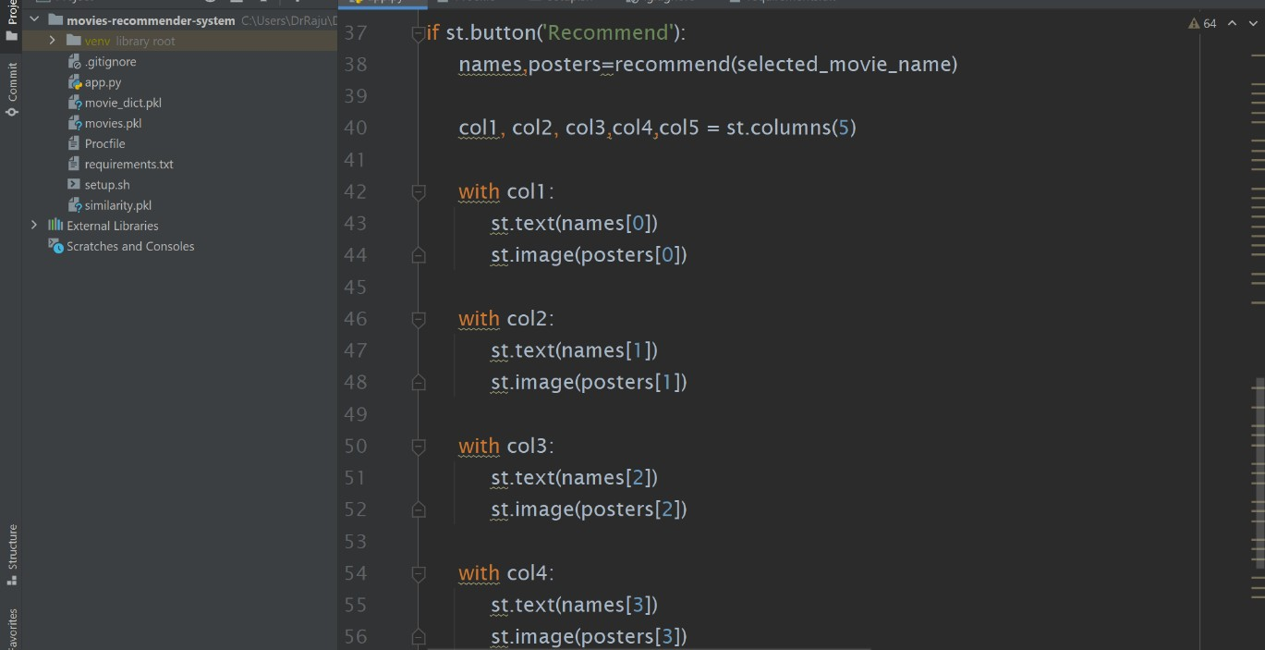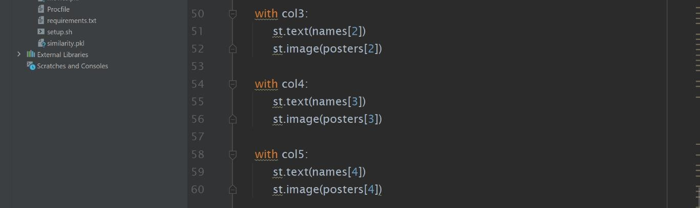

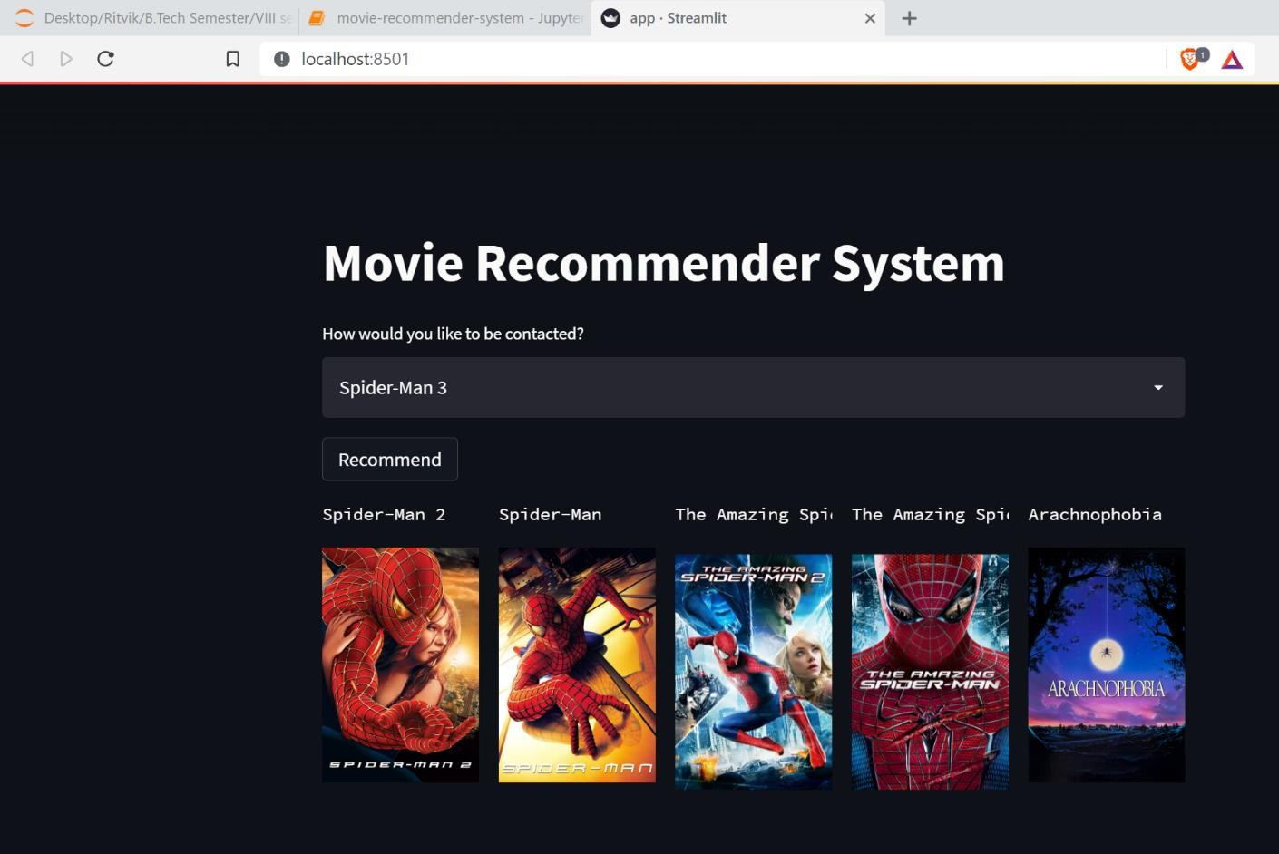

* 1. Heroku Dashboard & Web App

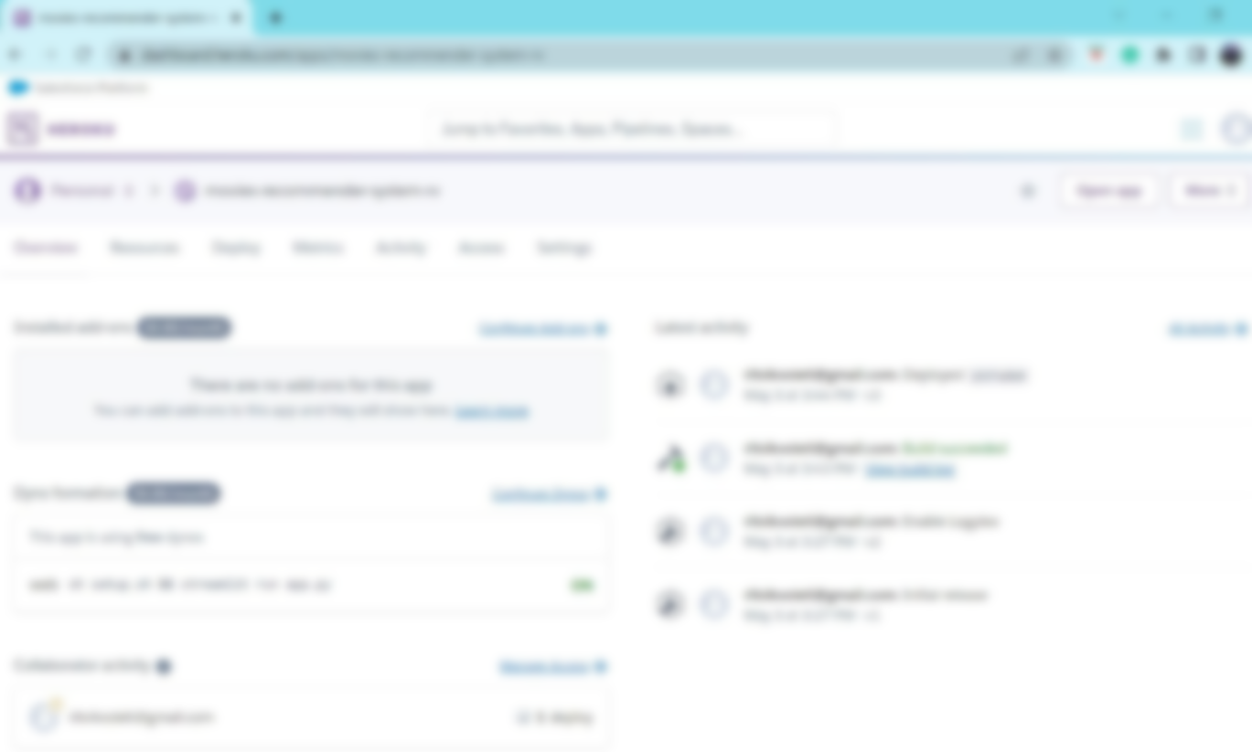

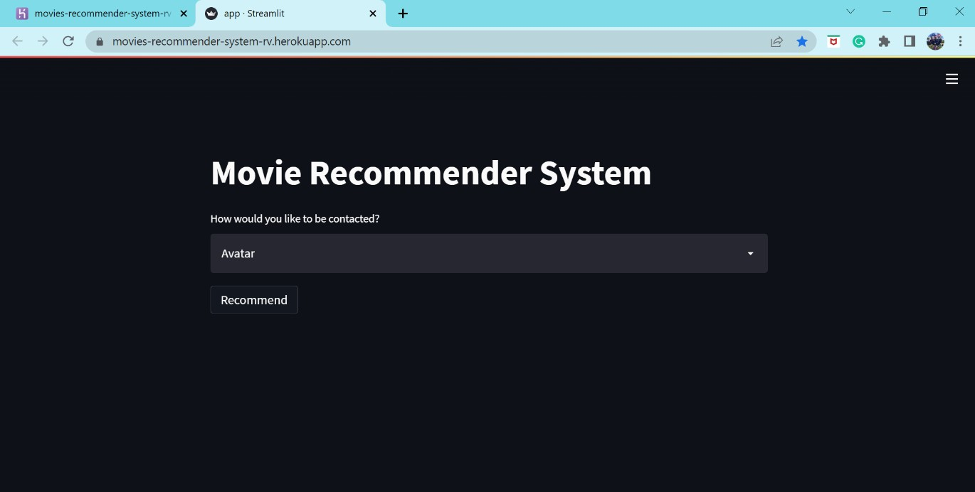

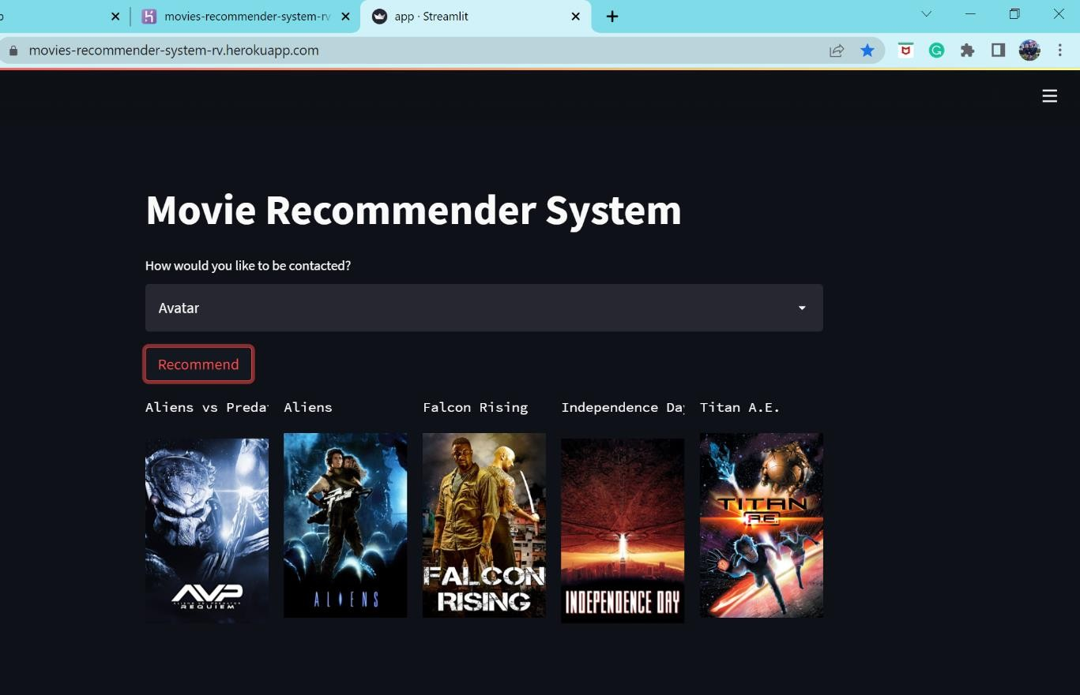

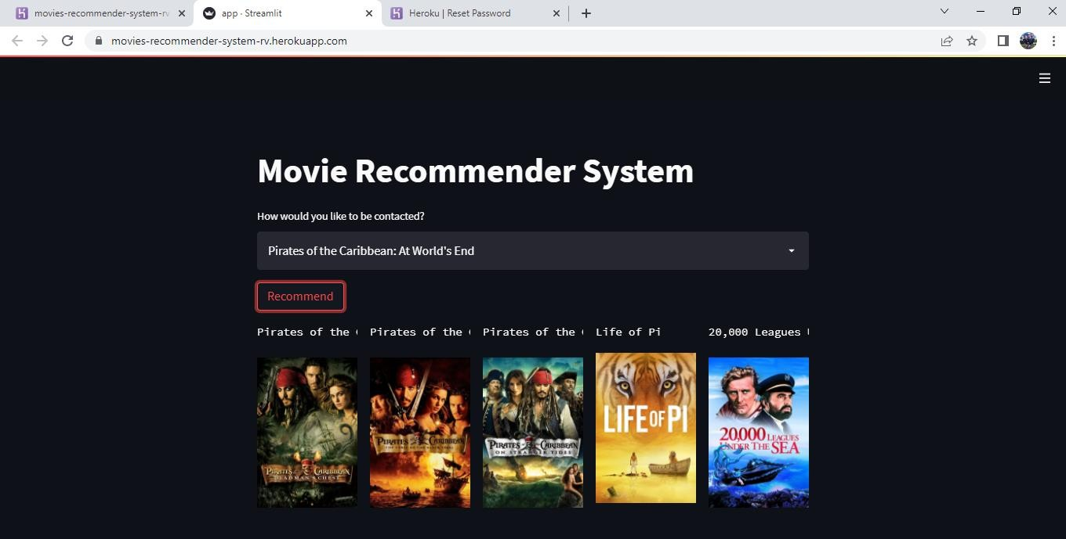

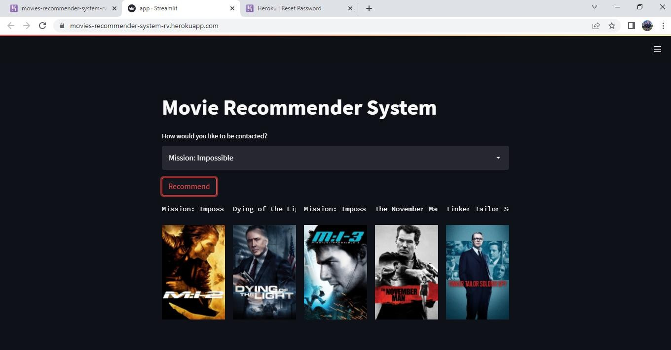

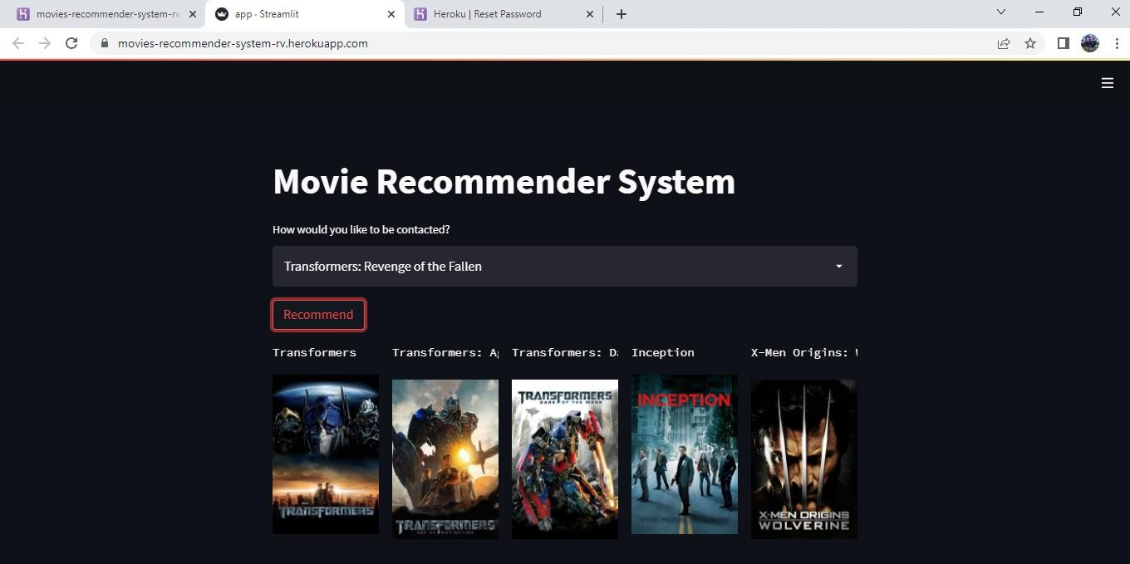

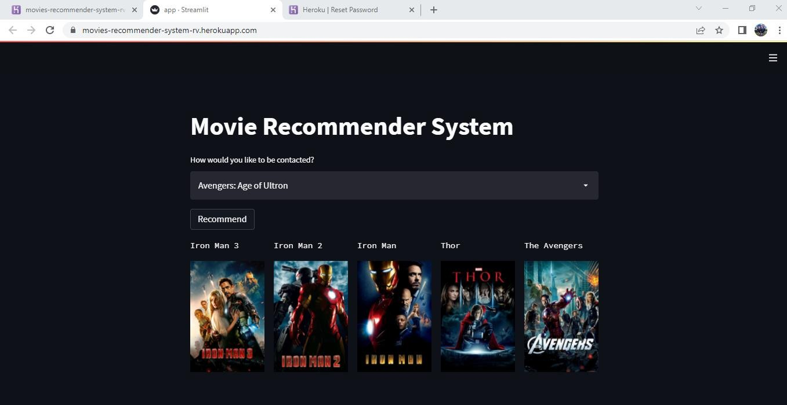

## CHAPTER 7: CONCLUSION AND FUTURE WORK



#### Conclusion

In this paper we have created and deployed a recommender system for movie recommendation. It allows a user to select his choices from a given set of attributes and then recommend him a movie list based on the cumulative weight of different attributes. By the nature of our system, it is not an easy task to evaluate the performance since there is no right or wrong recommendation; it is just a matter of opinions. Based on informal evaluations that we carried out over a small set of users we got a positive response from them. We would like to have a larger data set that will enable more meaningful results using our system. Additionally we would like to incorporate different machine learning and clustering algorithms and study the comparative results. Eventually we would like to implement a web based user interface that has a user database, and has the learning model tailored to each user.

Over the last decades recommender systems emerged as a significant information filtering system. It uses several techniques for recommendation which includes content-based, collaborative and hybrid methods. However in spite of all this advancement, the trends followed by recommender system of current generation surveyed in this paper still requires further modifications to make better recommendation. We reviewed various problems that are faced by techniques followed by recommender system and discussed possible solutions that

can help in providing better recommendations.

It opens new opportunities of retrieving personalized information on the Internet. It also helps to alleviate the problem of information overload which is a very common phenomenon and enables users to have access to products and services which are not readily available to users on the system.

* 1. **Future Scope**

Our System can be converted into a Hybrid Recommendation System by clubbing the techniques of content-based system and collaborative techniques. Such systems are more complex and highly effective and accurate to user’s needs and tastes. MNC’s like Google Inc. are using them in their video streaming platforms like Youtube.

Some better Machine Learning techniques can be applied to calculate accuracy scores of our suggestions as well in case of large user database at our end.

The Several recommendation systems have been proposed that are based on collaborative filtering, content and hybrid recommendation methods but these have some problems which are the challenges for research work. It is required to work on this research area to explore and provide new methods that can reduce the challenges and provide recommendation in collaborating filtering a wide range of applications while considering the quality and privacy aspects. Thus, the current recommendation system needs improvement for present and future requirements of better recommendation qualities.

## REFERENCES



* + - Meenakshi Sharma, Sandeep Mann-“A Survey of Recommender Systems: Approaches and Limitations”
    - International Journal of Innovations in Engineering and Technology ICAECE-2013, ISSN : 2319-1058.
    - Kaggle:
    - Wikipedia:
    - ResearchGate:
    - How Computers Know What We Want — Before We Do [(http://www.tim](http://www.time.com/time/magazine/article/0%2C9171%2C1992403%2C00.html))e[.com/time/magazine/article/0,9171,1992403,00.html)](http://www.time.com/time/magazine/article/0%2C9171%2C1992403%2C00.html))
    - Francesco Ricci and Lior Rokach and Bracha Shapira, “Introduction to Recommender Systems Handbook “,Springer, 2011
    - RVVSV Prasad and V Valli Kumari, “A Categorial review of recommender systems”, 2012